Name______________________________________ Period________________ Date______________________
Salmon Head Dissection Lab KEY

Observation Worksheet
- Draw and label the main external features and organs you can see on the salmon head (include eye, nostril, gill cover, maxilla, mandible, mouth, tongue, teeth, and scales)

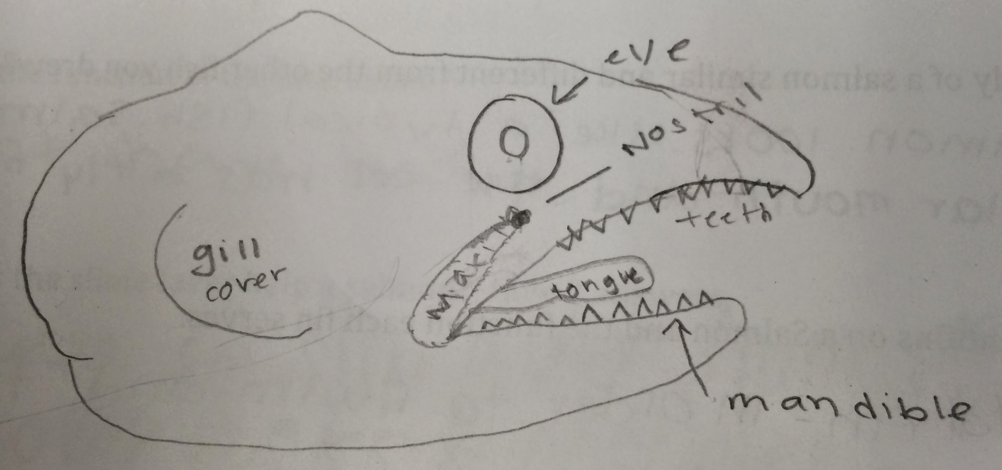
Here is an example of a head drawn by an actual student.
NOTE: the heads did not have any scales on them, so they were not included in the drawing.

- What species is your salmon? Chinook or Atlantic? How do you know?
Use the identification guide in the “Salmon Head Dissection Lab” instructions.
NOTE: Catalina offshore products told us that they gave us a mix of Chinook and Atlantic salmon heads. This lesson was written before the heads were received. It turns out that the heads were all from Chinook salmon. They did not give us any Atlantic salmon.
- Pick one fish at the front of the classroom to draw. Label all the parts as shown in figure 1 of the “Salmon Head Dissection Lab” instructions. Be sure to include the name of the species.
(Student draws one of the fish in front of the class). Below is figure 1 from the “Salmon Head Dissection Lab” instructions.
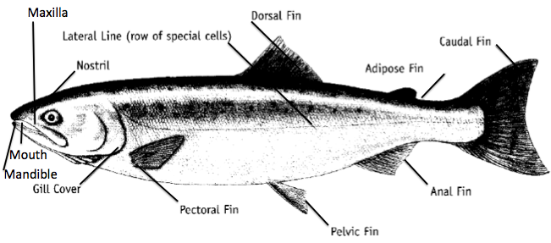
- What type of environment do you think this fish lives in, and why do you think that? Look at the provided “Fish Body Forms” Sheet. Think about different ocean environments (on the bottom, open ocean, deep sea, near the coast were there are rocks/weeds/other structures) and how different body forms might be best suited for a particular environment.

NOTE to Teacher: Encourage students to think about the body form and fin adaptations of the fish. Is the fish flat/depressed, torpedo shaped, long and eel-like? Students should use the “Fish Body Forms” PDF for help.

- How is the body of a salmon similar and different from the other fish you drew?

The student should describe the differences and similarities between their fish and the salmon. Think about the shape of the body, the location of the fins, shape of the mouth, teeth, size of the eye.

- Name 3 different fins on a Salmon and the function each fin serves.

The caudal fin or tail, is the largest and most powerful. It pushes from side to side and moves the fish forward in a wavy path. The dorsal fin acts like a keel on a ship. It keeps the fish upright, and it also controls the direction the fish moves in. The anal fin also helps keep the fish stable and upright. The pectoral and pelvic fins are used for steering and for balance. They can also move the fish up and down in the water.

- Which salmon fin has no known function?
The adipose fin has no known function

- Are there any fins attached to your fish head? If so, which one(s)?

Some of the heads may have pectoral fins still attached.

- Remove one set of gills and gill raker and draw it.

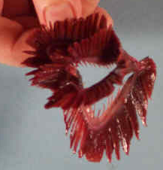

The students should remove and draw the structure above.

- Gills and gill rakers – write three observations about the gills and gill rakers.
The gills are red because they are filled with blood, which picks up oxygen as water passes over them.
Gill filaments are attached to the gill arches. They are very fine like the filaments of a feather and are filled with capillaries that carry blood from the heart.
Fish breathe by gulping water through their mouth forcing water over their gills and out through the gill plate opening.

- What is the function of the lateral line?
The lateral line functions as a sensory organ combining aspects of touch, hearing, and seeing. It detects vibrations and pressure waves in water, similar to what an ear does in air, and allows fish to sense water flow and disturbances.
- How does the slime layer help a salmon? Give 2 answers.
  - Slip away from predators, including bears or other fish.
  - Slip over rocks or other obstacles to avoid injuries
  - Protect against diseases, parasites, and pollutants.

- Draw a salmon (or other fish) scale - showing its growth lines (there should be a scale set up under a microscope at the front of the class).

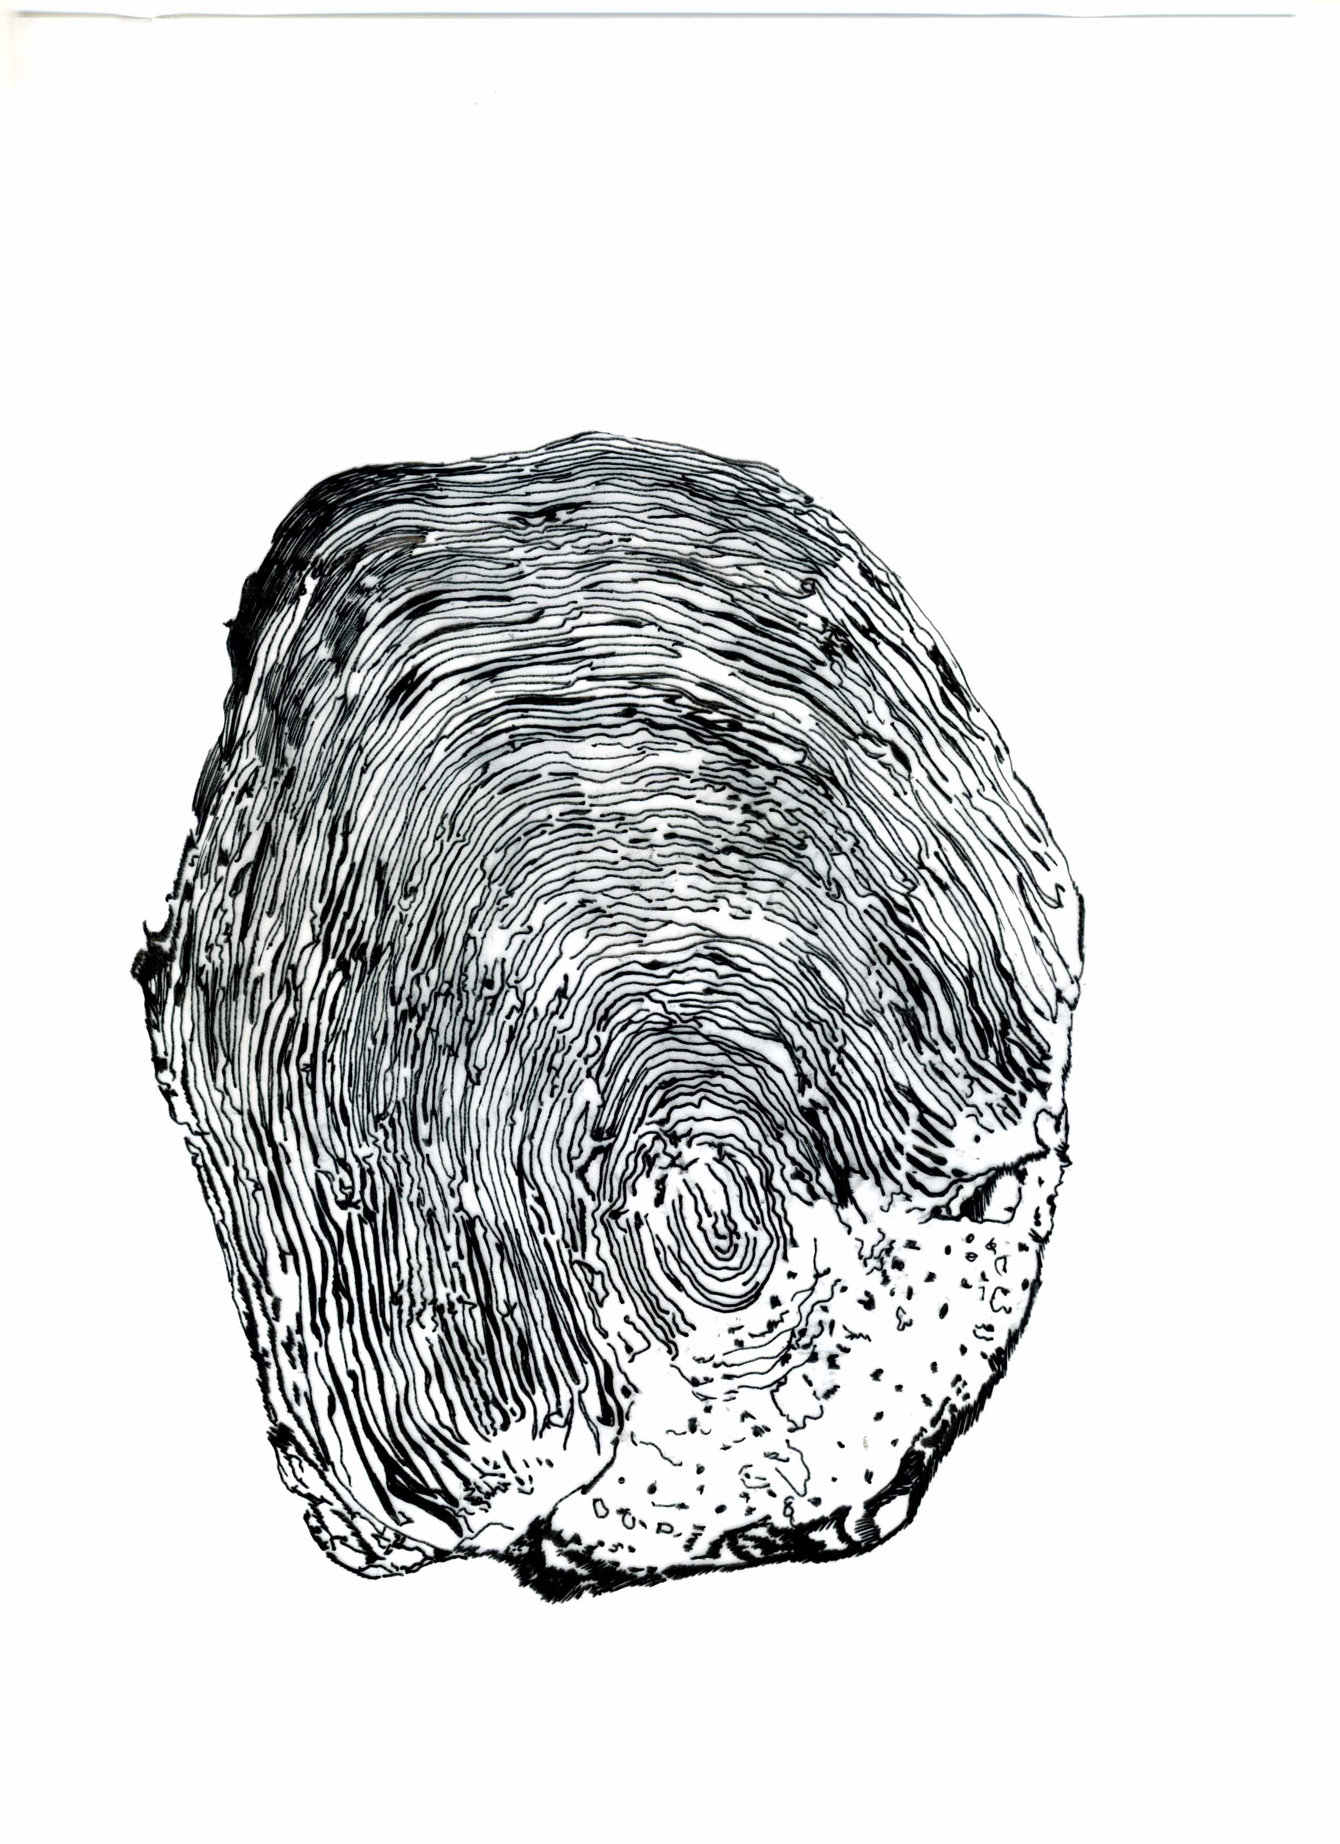The scale should look something like the scale above.

- What sense organs are located on the outside of the salmon head?

Eyes, nostrils.

- What organs are located inside of the salmon head?

Inner ears, otoliths, tongue, brain, spine.

- Did you find both otoliths? Did you break any of them?

Yes or no. They can be difficult to find and easy to break!

- Draw one of the otoliths.
The otolith should look like this:
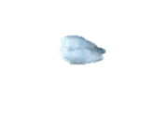

- Otolith length (mm) ____typically between 3-12mm_______________

- Otolith width (mm) _____typically between 1 and 6 mm______________

- Draw the location of the brain on your sketch of the salmon’s head from question 1.

