
Journal of Geophysical Research: Solid Earth
Supporting Information for
The 1.24–1.21 Ga Licheng large igneous province in the North China Craton: Implications for paleogeographic reconstruction
Chong Wang^{1,2,3}, Peng Peng^{2,3}, Zheng-Xiang Li¹, Sergei Pisarevsky¹, Steven Denyszyn⁴, Yebo Liu¹, Hamed Gamal El Dien^{1,5}, Xiangdong Su^{2,3}
¹ Earth Dynamics Research Group, The Institute for Geoscience Research (TIGeR), School of Earth and Planetary Sciences, Curtin University, WA 6845, Australia
² State Key Laboratory of Lithospheric Evolution, Institute of Geology and Geophysics, Chinese Academy of Sciences, Beijing 100029, China
³ College of Earth and Planetary Sciences, University of Chinese Academy of Sciences, Beijing 100049, China
⁴ School of Earth Sciences, University of Western Australia, WA 6009, Australia
⁵ Geology Department, Faculty of Science, Tanta University, 31527 Tanta, Egypt

Corresponding author: Chong Wang (chong.wang1@postgrad.curtin.edu.au; wangchong@mail.iggcas.ac.cn)
Current address: Gustaf Hällströminkatu 2, Physicum building, Department of geosciences and geography, University of Helsinki, P.O. Box 64, 00014, Finland

Contents of this file

Figures S1 to S4
Tables S1 to S5

Introduction
This supporting information contains 4 figures and 5 tables described in the manuscript.
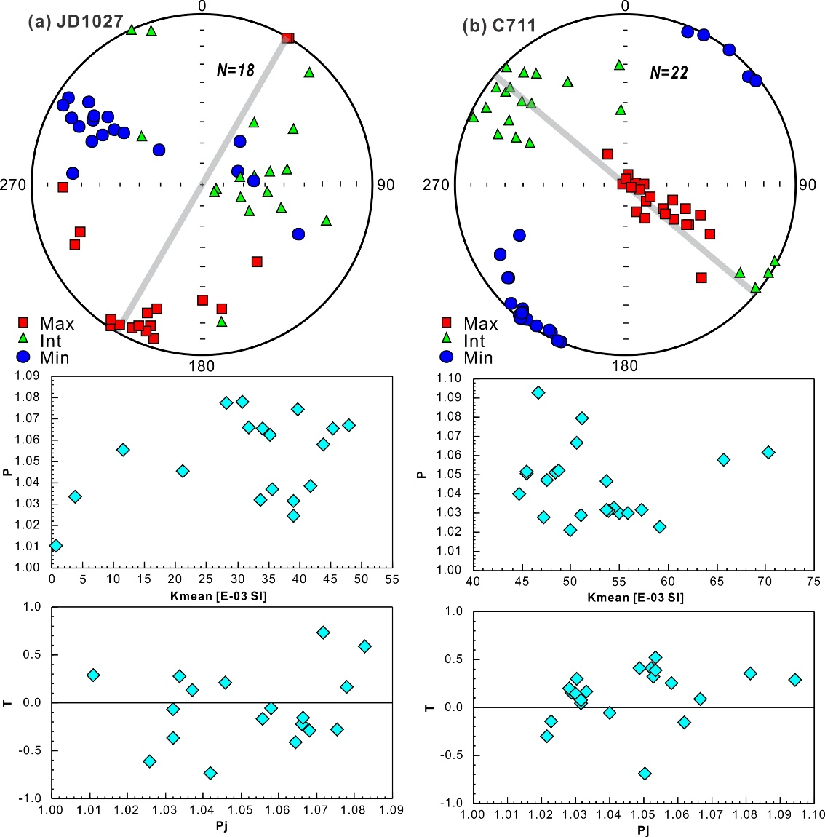
Figure S1. Equal-area projections of anisotropy of magnetic susceptibility (AMS) in geographic coordinates. Each dyke includes three axes equal-area projection (grey line marks trend of dyke), P-Kmean and T-Pj diagrams.
The mean bulk susceptibility is calculated as the mean of three susceptibility axes (K1 ≥ K2 ≥ K3). The degree of anisotropy is defined as P = K1/K3, or Pj = exp (2((η₁- η_{m})² + (η₂- η_{m})² + (η₃- η_{m})²))^{1/2}, η_{i} = lnKi; η_{m} = (η₁η₂η₃)^{1/3}, standing for the intensity of the preferred orientation of magnetic minerals in rock. The shape of the magnetic fabric (the AMS ellipsoid) is defined by the parameter T = 2 × ln(K1/K2) / ln(K2/ K3) -1, where 0~1 and -1~0 respectively correspond to oblate (when the magnetic fabric is planar) and prolate (when the magnetic fabric is linear) (Tarling and Hrouda, 1993).

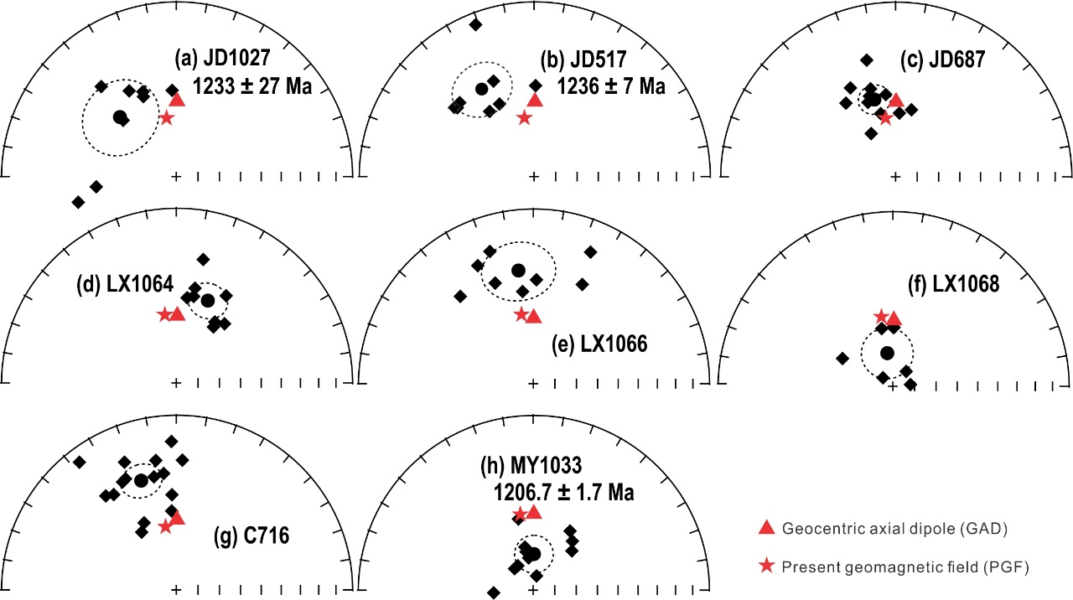
Figure S2. Equal-area projections showing the low temperature components (LTCs). One diamond represents one sample. Circles and their dashed lines represent the site mean directions and α₉₅. Solid symbols represent lower hemisphere vectors. Age details are in Table 1.
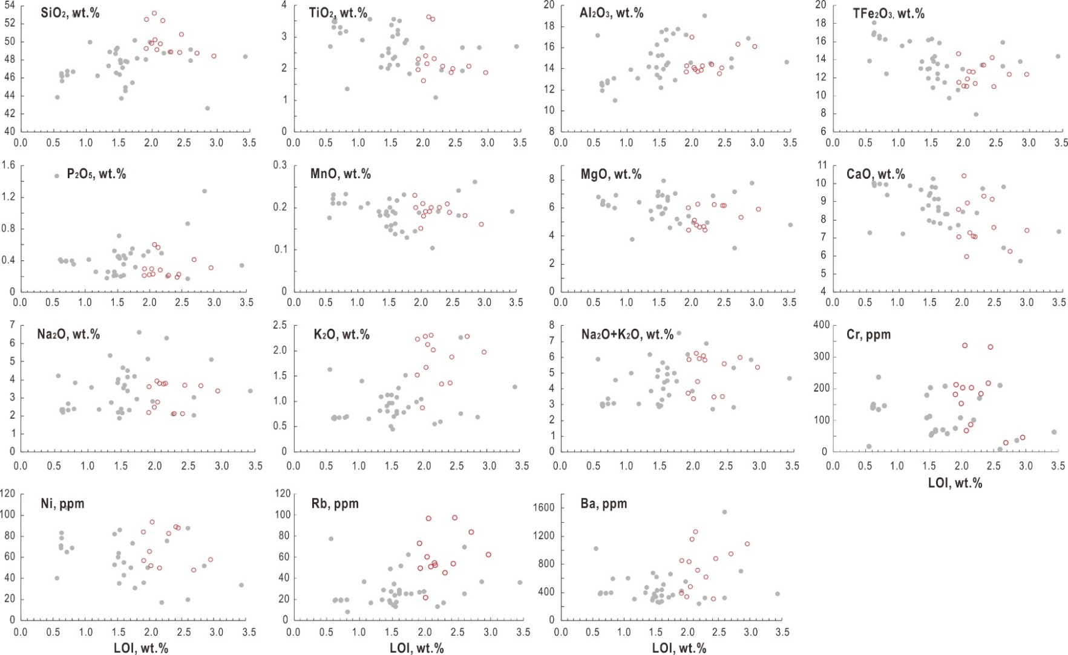
Figure S3. Loss on ignition (LOI) vs. whole rock elements. Red represents new data in this study. Grey represents samples from reported and dated dykes/ intrusions (N = 37), see Table S5
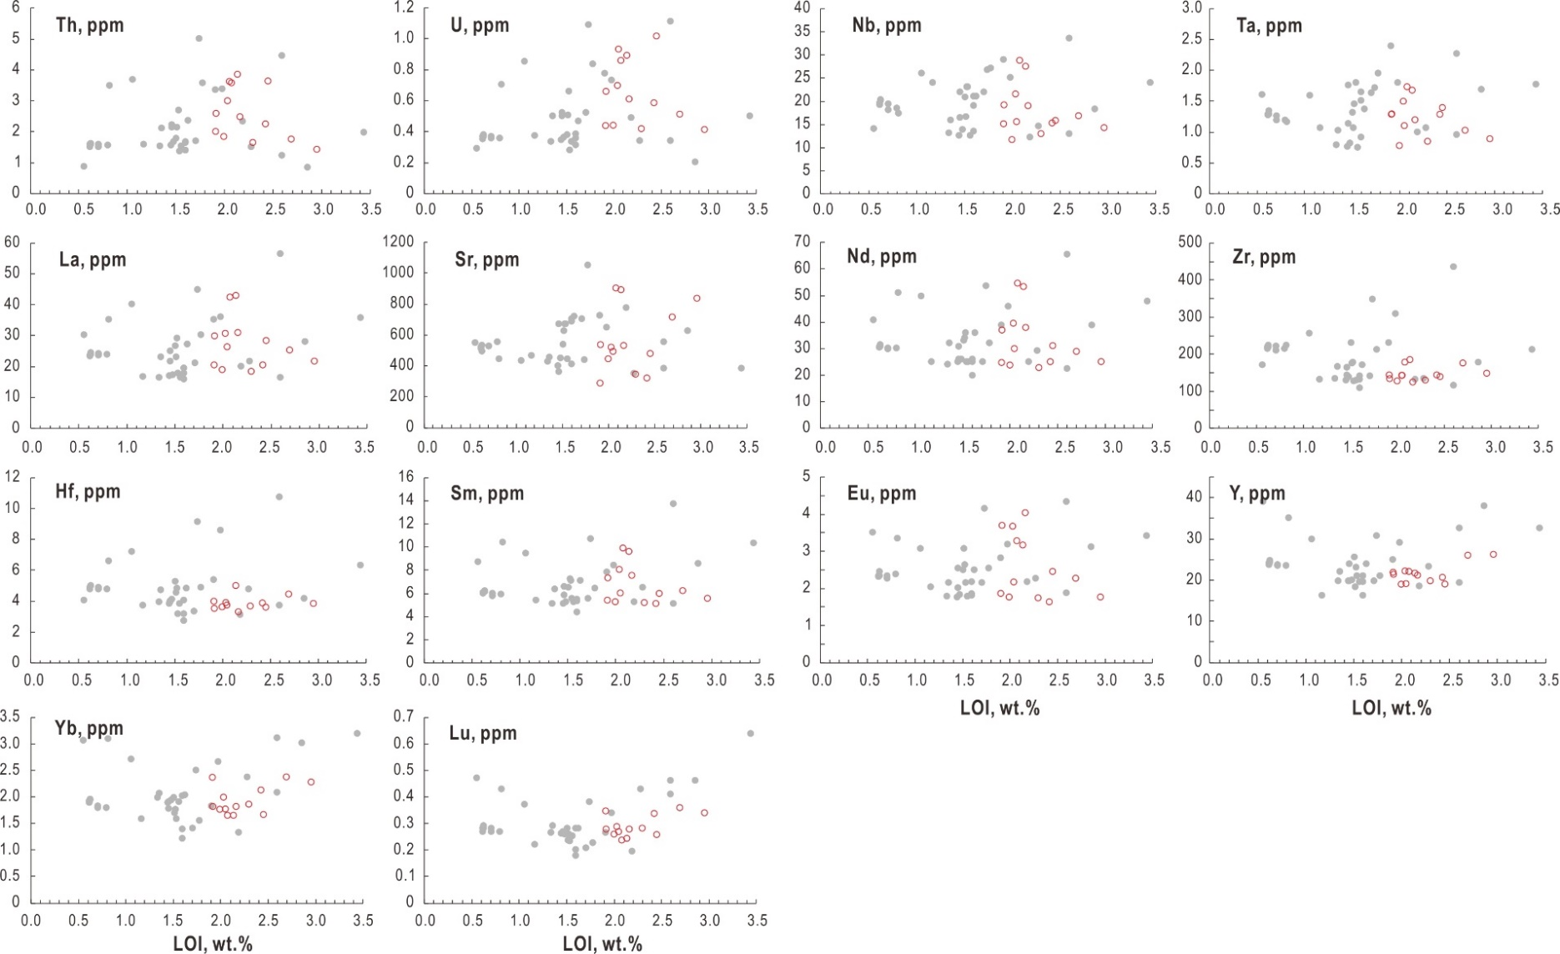
Continued Figure S3
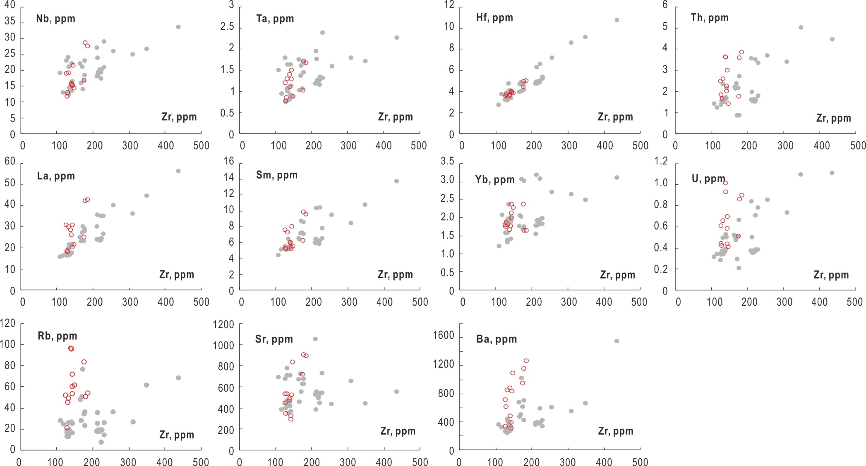
Figure S4. Zr vs. whole rock elements. Legends see Figure S3.
Table S1. Pb–Pb SIMS data for baddeleyites dating of the Laowangjia dyke (JD1027)
Spot | ²⁰⁴Pb (cps.) | ²⁰⁶Pb/²⁰⁴Pb | ²⁰⁷Pb/²⁰⁶Pb_{c} | ± 1σ % | ²⁰⁷Pb/²⁰⁶Pb (Ma) | ± 1σ %
1 | 48.8 | 1069 | 0.081 | 8.59 | 1217.0 | 338
2 | 12.6 | 6699 | 0.080 | 0.66 | 1202.3 | 26
3 | 17.1 | 7766 | 0.076 | 9.58 | 1084.6 | 384
4 | 56.6 | 1358 | 0.081 | 0.89 | 1232.2 | 35
5 | 2.2 | 47966 | 0.082 | 0.48 | 1246.2 | 19
6 | 5.8 | 17229 | 0.084 | 2.12 | 1303.2 | 82
cps., counts per second; ²⁰⁷Pb/²⁰⁶Pb_{c}, corrected ²⁰⁷Pb/²⁰⁶Pb;

Table S2. U–Pb TIMS data for baddeleyites dating of mafic dykes
Grain | wt.  (μg) | U  (ppm) | Pb_{c}  (pg) | mol%  Pb* | Th  U | ²⁰⁶Pb  ²⁰⁴Pb | ²⁰⁷Pb  ²⁰⁶Pb | ± 2σ  (%) | ²⁰⁷Pb  ²³⁵U | ± 2σ  (%) | ²⁰⁶Pb  ²³⁸U | ± 2σ  (%) | ρ | ²⁰⁶Pb/²³⁸U  Age (Ma) | ± 2σ  (Ma) | ²⁰⁷Pb/²⁰⁶Pb  Age (Ma) | ± 2σ  (Ma)
Sample 1033BHJ1
1 | 0.1 | 131 | 0.9 | 94 | 0 | 197 | 0.0803 | 0.5 | 2.186 | 0.5 | 0.197369 | 0.1 | 0.5 | 1161.17 | 1.22 | 1205 | 8.8
2 | 0.1 | 174 | 0.3 | 97 | 0.1 | 572 | 0.0803 | 0.2 | 2.221 | 0.2 | 0.200563 | 0.1 | 0.7 | 1178.34 | 1.5 | 1205 | 3.2
3 | 0.1 | 85 | 0.3 | 95 | 0.1 | 330 | 0.0806 | 0.4 | 2.218 | 0.5 | 0.199551 | 0.1 | 0.6 | 1172.91 | 1.38 | 1212 | 8.2
4 | 0.1 | 164 | 0.5 | 94 | 0.1 | 346 | 0.0805 | 0.2 | 2.087 | 0.3 | 0.188052 | 0.1 | 0.6 | 1110.81 | 1.19 | 1209 | 4.5
5 | 0.2 | 218 | 0.5 | 99 | 0.1 | 977 | 0.0804 | 0.1 | 2.105 | 0.2 | 0.18983 | 0.1 | 0.8 | 1120.45 | 1.22 | 1207 | 2.5
Sample 1036QL1
1 | 0.2 | 231 | 0.4 | 92 | 0.1 | 1377 | 0.0805 | 0.9 | 2.11 | 1 | 0.190042 | 0.1 | 0.8 | 1121.6 | 1.58 | 1209 | 17.6
2 | 0.1 | 193 | 0.6 | 94 | 0.1 | 428 | 0.0803 | 0.9 | 2.287 | 1 | 0.206590 | 0.2 | 0.7 | 1210.62 | 1.91 | 1204 | 17.2
3 | 0.2 | 276 | 3.1 | 81 | 0.1 | 245 | 0.0808 | 3.4 | 2.281 | 3.8 | 0.204732 | 0.4 | 1.0 | 1200.69 | 4.57 | 1217 | 66.6
4 | 0.2 | 178 | 0.4 | 97 | 0 | 938 | 0.0808 | 1.2 | 2.262 | 1.3 | 0.203065 | 0.2 | 0.9 | 1191.77 | 1.91 | 1216 | 23.3
5 | 0.2 | 224 | 0.3 | 91 | 0.1 | 1596 | 0.0808 | 0.4 | 2.306 | 0.5 | 0.206913 | 0.1 | 0.7 | 1212.35 | 1.27 | 1217 | 7.6
6 | 0.2 | 180 | 0.3 | 95 | 0 | 1345 | 0.0807 | 0.4 | 2.186 | 0.5 | 0.196529 | 0.1 | 0.7 | 1156.65 | 1.26 | 1213 | 8.6
Sample 1050MP1
1 | 0.2 | 187 | 1.8 | 84 | 0.03 | 146 | 0.08174 | 0.61 | 2.3547 | 0.67 | 0.208917 | 0.11 | 0.6 | 1223.04 | 1.38 | 1239 | 11.9
2 | 0.1 | 187 | 1.1 | 82 | 0.01 | 121 | 0.08170 | 0.65 | 2.3832 | 0.72 | 0.211568 | 0.12 | 0.6 | 1237.17 | 1.47 | 1238 | 12.8
3 | 0.2 | 198 | 0.6 | 95 | 0.06 | 401 | 0.08154 | 0.36 | 2.3731 | 0.42 | 0.211071 | 0.10 | 0.6 | 1234.52 | 1.28 | 1235 | 7.1
4 | 0.1 | 139 | 0.7 | 79 | 0.06 | 89 | 0.08163 | 1.39 | 2.3847 | 1.54 | 0.211886 | 0.21 | 0.8 | 1238.86 | 2.65 | 1237 | 27.2
Weights are calculated from crystal dimensions and are associated with as much as 50% uncertainty (estimated)
Pb_{c} = Total common Pb including analytical blank (0.8 ± 0.3 pg per analysis).
Blank composition is: ²⁰⁶Pb/²⁰⁴Pb = 18.55 ± 0.63, ²⁰⁷Pb/²⁰⁴Pb = 15.50 ± 0.55, ²⁰⁸Pb/²⁰⁴Pb = 38.07 ± 1.56 (all 2σ), and a ²⁰⁶Pb/²⁰⁴Pb – ²⁰⁷Pb/²⁰⁴Pb correlation of 0.9.
Th/U calculated from radiogenic ²⁰⁸Pb/²⁰⁶Pb and age.
Measured isotopic ratios corrected for tracer contribution and mass fractionation (0.04 ± 0.09 %/amu).
ρ = error correlation coefficient of radiogenic ²⁰⁷Pb/²³⁵U vs. ²⁰⁶Pb/²³⁸U.
Ratios involving ²⁰⁶Pb are corrected for initial disequilibrium in ²³⁰Th/²³⁸U using Th/U = 4 in the crystallization environment.

Table S3. Major (wt.%) and trace (ppm) elements of 1.24–1.21 Ga mafic dykes
Sample | 1008XT1 | 1009DT1 | 1027LW1 | 1027LW2 | 716RJD1 | 716RJD2 | 711NG22 | 711NG4 | 323WCZ2 | 1064JP1 | 1066XZ1 | 1066XZ2 | 1068-2
SiO₂ | 48.4 | 48.7 | 49.8 | 48.8 | 49.1 | 49.7 | 49.3 | 48.8 | 52.5 | 50.8 | 52.4 | 53.2 | 50.3
TiO₂ | 1.87 | 2.07 | 1.61 | 2.07 | 3.63 | 3.56 | 1.97 | 1.87 | 2.29 | 2.00 | 2.30 | 2.39 | 2.15
Al₂O₃ | 16.1 | 16.3 | 17.0 | 14.4 | 13.8 | 13.9 | 13.7 | 13.6 | 14.2 | 14.1 | 14.3 | 14.1 | 13.9
tFe₂O₃ | 12.4 | 12.4 | 11.1 | 13.4 | 12.7 | 12.6 | 14.7 | 14.2 | 11.4 | 11.0 | 11.3 | 11.0 | 11.8
MnO | 0.16 | 0.18 | 0.15 | 0.20 | 0.19 | 0.19 | 0.23 | 0.21 | 0.20 | 0.19 | 0.20 | 0.21 | 0.18
MgO | 5.88 | 5.28 | 5.09 | 6.21 | 4.6 | 4.64 | 5.98 | 6.16 | 4.38 | 6.15 | 4.39 | 4.74 | 6.22
CaO | 7.40 | 6.25 | 10.43 | 9.31 | 7.27 | 7.10 | 8.57 | 9.12 | 7.04 | 7.55 | 7.02 | 5.93 | 8.89
Na₂O | 3.37 | 3.67 | 2.47 | 2.13 | 3.78 | 3.77 | 2.20 | 2.15 | 3.61 | 3.70 | 3.79 | 3.94 | 2.76
K₂O | 1.97 | 2.28 | 0.87 | 1.34 | 2.12 | 2.31 | 1.52 | 1.36 | 2.22 | 1.88 | 2.01 | 2.28 | 1.66
P₂O₅ | 0.31 | 0.42 | 0.22 | 0.21 | 0.60 | 0.57 | 0.21 | 0.19 | 0.29 | 0.23 | 0.28 | 0.29 | 0.23
LOI | 2.96 | 2.70 | 2.00 | 2.30 | 2.08 | 2.14 | 1.91 | 2.42 | 1.92 | 2.45 | 2.15 | 2.02 | 2.05
Total | 100.8 | 100.2 | 100.7 | 100.4 | 99.8 | 100.5 | 100.2 | 100.1 | 100.1 | 100.1 | 100.1 | 100.1 | 100.1
Mg# | 48.7 | 46.0 | 47.8 | 48.1 | 42.0 | 42.4 | 44.9 | 46.5 | 43.4 | 52.7 | 43.7 | 46.2 | 51.3
Cr | 44.2 | 27.9 | 151 | 181 | 65.7 | 85.3 | 181 | 215 | 212 | 329 | 202 | 202 | 336
Ni | 57.7 | 47.7 | 65.4 | 82.4 |  |  | 84.0 | 88.7 | 56.9 | 87.6 | 49.6 | 51.6 | 93.0
Rb | 62.0 | 83.7 | 21.1 | 45.0 | 50.6 | 53.9 | 72.3 | 53.4 | 49.1 | 96.6 | 52.1 | 60.1 | 96.0
Ba | 1091 | 950 | 335 | 618 | 1157 | 1266 | 389 | 313 | 853 | 881 | 710 | 830 | 478
Th | 1.42 | 1.76 | 1.84 | 1.64 | 3.59 | 3.86 | 2.00 | 2.26 | 2.59 | 3.63 | 2.46 | 2.99 | 3.61
U | 0.41 | 0.51 | 0.44 | 0.42 | 0.86 | 0.89 | 0.44 | 0.59 | 0.66 | 1.02 | 0.61 | 0.70 | 0.93
Nb | 14.3 | 16.8 | 11.7 | 12.9 | 28.7 | 27.5 | 15.1 | 15.4 | 19.2 | 15.8 | 18.9 | 21.5 | 15.5
Ta | 0.88 | 1.02 | 0.78 | 0.85 | 1.72 | 1.68 | 1.3 | 1.3 | 1.3 | 1.4 | 1.2 | 1.5 | 1.1
La | 21.7 | 25.1 | 18.7 | 18.1 | 42.2 | 42.7 | 20.4 | 20.6 | 29.9 | 28.5 | 30.8 | 30.7 | 26.2
Ce | 40.5 | 51.7 | 39.7 | 38.8 | 92.7 | 91.9 | 45.5 | 45.3 | 65.4 | 56.2 | 66.2 | 68.6 | 56.4
Pr | 5.91 | 7.07 | 5.57 | 5.48 | 12.5 | 12.3 | 5.81 | 6.03 | 8.71 | 7.39 | 9.09 | 9.42 | 7.37
Sr | 835 | 716 | 447 | 347 | 901 | 894 | 293 | 324 | 534 | 479 | 531 | 520 | 492
Nd | 25.1 | 29.0 | 23.8 | 22.9 | 54.8 | 53.4 | 24.7 | 25.0 | 36.9 | 31.1 | 37.9 | 39.4 | 30.0
Zr | 149 | 176 | 128 | 130 | 179 | 185 | 143 | 143 | 133 | 139 | 124 | 142 | 141
Hf | 3.81 | 4.41 | 3.57 | 3.67 | 4.93 | 4.98 | 4.0 | 3.9 | 3.5 | 3.6 | 3.3 | 3.9 | 3.7
Sm | 5.54 | 6.2 | 5.21 | 5.13 | 9.85 | 9.58 | 5.43 | 5.18 | 7.34 | 6.05 | 7.58 | 8.04 | 6.05
Sample | 1008XT1 | 1009DT1 | 1027LW1 | 1027LW2 | 716RJD1 | 716RJD2 | 711NG22 | 711NG4 | 323WCZ2 | 1064JP1 | 1066XZ1 | 1066XZ2 | 1068-2
Eu | 1.75 | 2.26 | 1.77 | 1.74 | 3.29 | 3.16 | 1.88 | 1.65 | 3.68 | 2.45 | 4.02 | 3.66 | 2.16
Gd | 5.46 | 6.04 | 4.99 | 4.97 | 8.18 | 7.91 | 5.23 | 4.68 | 6.29 | 5.64 | 6.64 | 6.72 | 5.29
Tb | 0.84 | 0.92 | 0.75 | 0.75 | 1.09 | 1.05 | 0.78 | 0.72 | 0.88 | 0.78 | 0.90 | 0.95 | 0.74
Dy | 4.84 | 5.15 | 4.08 | 4.04 | 5.17 | 5.13 | 4.44 | 4.20 | 4.70 | 4.24 | 4.69 | 5.10 | 4.07
Y | 26.1 | 25.9 | 18.9 | 19.7 | 22.1 | 21.6 | 22.0 | 20.8 | 21.3 | 19.1 | 21.2 | 22.2 | 19.1
Ho | 0.95 | 1.0 | 0.75 | 0.76 | 0.94 | 0.92 | 0.93 | 0.84 | 0.89 | 0.81 | 0.91 | 0.91 | 0.77
Er | 2.50 | 2.61 | 1.98 | 2.06 | 2.20 | 2.16 | 2.46 | 2.25 | 2.19 | 2.06 | 2.24 | 2.44 | 2.08
Tm | 0.37 | 0.38 | 0.29 | 0.30 | 0.28 | 0.28 | 0.36 | 0.34 | 0.30 | 0.28 | 0.31 | 0.34 | 0.29
Yb | 2.28 | 2.38 | 1.76 | 1.86 | 1.65 | 1.65 | 2.38 | 2.14 | 1.81 | 1.67 | 1.81 | 1.99 | 1.77
Lu | 0.34 | 0.36 | 0.26 | 0.28 | 0.24 | 0.24 | 0.35 | 0.34 | 0.28 | 0.26 | 0.28 | 0.29 | 0.27
Eu* | 0.97 | 1.13 | 1.06 | 1.05 | 1.12 | 1.11 | 1.08 | 1.02 | 1.66 | 1.28 | 1.73 | 1.52 | 1.17
REE | 118 | 140 | 110 | 107 | 235 | 232 | 121 | 119 | 169 | 147 | 173 | 179 | 143
Nb/Y | 0.546 | 0.647 | 0.618 | 0.657 | 1.30 | 1.27 | 0.686 | 0.740 | 0.901 | 0.827 | 0.892 | 0.968 | 0.812
La/Sm | 3.91 | 4.05 | 3.59 | 3.54 | 4.28 | 4.46 | 3.76 | 3.98 | 4.07 | 4.71 | 4.06 | 3.82 | 4.33
Th/Nb | 0.10 | 0.10 | 0.16 | 0.13 | 0.13 | 0.14 | 0.13 | 0.15 | 0.13 | 0.23 | 0.13 | 0.14 | 0.23
Nb/La | 0.66 | 0.67 | 0.63 | 0.71 | 0.68 | 0.64 | 0.74 | 0.75 | 0.64 | 0.55 | 0.61 | 0.70 | 0.59
La/Yb_{N} | 6.82 | 7.56 | 7.62 | 7.00 | 18.3 | 18.6 | 6.15 | 6.90 | 11.85 | 12.24 | 12.21 | 11.07 | 10.62
Th/Yb | 0.62 | 0.74 | 1.05 | 0.88 | 2.17 | 2.35 | 0.84 | 1.06 | 1.43 | 2.17 | 1.36 | 1.50 | 2.04
Nb/Yb | 6.25 | 7.05 | 6.65 | 6.96 | 17.3 | 16.7 | 6.34 | 7.20 | 10.6 | 9.46 | 10.4 | 10.8 | 8.76
Zr/Y | 5.69 | 6.79 | 6.76 | 6.60 | 8.07 | 8.57 | 6.50 | 6.88 | 6.24 | 7.28 | 5.85 | 6.40 | 7.38
tFe₂O₃, total Fe₂O₃; MgO# = 100*Mg/ (FeO_{total} + MgO), in molecular; Eu/Eu* = Eu_{N}/[(Sm_{N}) × (Gd_{N})]^{1/2}; La/Yb_{N}, normalized to chondrite compositions, and hondrite normalized values are from Sun and McDonough (1989).

Table S4. Low temperature component results of paleomagnetic sites
Dyke ID  (Age/Ma) | n/N | Declination/° | Inclination/° | α₉₅/°
JD517  (1236 ± 7) | 8/13 | 329.2 | 41.5 | 13.2
JD687 | 11/12 | 344.7 | 52.3 | 7.1
JD1027  (1233 ± 27) | 8/12 | 316.6 | 51.4 | 17.6
C716 | 15/15 | 342.2 | 34.9 | 8.7
LX1064 | 8/15 | 20.9 | 48.4 | 8.7
LX1066 | 8/11 | 352.5 | 35.2 | 15.3
LX1068 | 6/11 | 350.4 | 74.4 | 11.9
MY1033  (1206.7 ± 1.7) | 11/13 | 1.3 | 73.3 | 8.9
n/N, number of samples in mean/ all measured;
α₉₅, 95% confidence interval; Age details are in Table 1.

Table S5. Compiled whole rock geochemistry data of 1.24–1.21 Ga intrusions in the North China Craton
Sample | 517MJG1 | 05LC06 | 07MY12 | DHZK01-1 | DHZK01-2 | DHZK01-3 | 12JP01-1 | 12JP01-2 | 11JP14-1 | 12JP03-1 | 12JP04-1 | 12JP07-2
Reference | 1 | 2 | 3 | 4 | 4 | 4 | 5 | 5 | 5 | 5 | 5 | 5
SiO₂ | 50.1 | 49.1 | 49.1 | 48.8 | 47.9 | 48.3 | 48.0 | 48.1 | 49.9 | 43.8 | 42.6 | 45.4
TiO₂ | 2.91 | 2.66 | 2.50 | 1.95 | 1.93 | 2.70 | 2.16 | 1.84 | 2.67 | 2.71 | 2.66 | 2.82
Al₂O₃ | 12.9 | 14.1 | 13.4 | 14.5 | 15.0 | 14.6 | 17.2 | 17.8 | 14.6 | 17.2 | 16.9 | 17.3
tFe₂O₃ | 13.3 | 15.9 | 16.2 | 13.4 | 13.3 | 14.4 | 10.7 | 9.7 | 13.0 | 13.9 | 13.8 | 11.5
MnO | 0.23 | 0.24 | 0.19 | 0.19 | 0.18 | 0.19 | 0.14 | 0.13 | 0.19 | 0.18 | 0.26 | 0.14
MgO | 5.18 | 3.12 | 6.05 | 6.84 | 7.10 | 4.74 | 5.39 | 4.84 | 4.92 | 6.74 | 7.75 | 7.01
CaO | 8.29 | 6.44 | 9.33 | 9.73 | 9.80 | 7.35 | 7.69 | 7.52 | 8.42 | 7.27 | 5.70 | 8.3
Na₂O | 2.92 | 3.03 | 2.18 | 2.09 | 2.02 | 3.36 | 5.15 | 6.63 | 2.80 | 4.22 | 5.12 | 4.17
K₂O | 1.52 | 2.26 | 0.799 | 0.600 | 0.760 | 1.28 | 0.982 | 0.884 | 1.04 | 1.63 | 0.690 | 0.78
P₂O₅ | 0.55 | 0.87 | 0.26 | 0.20 | 0.17 | 0.34 | 0.47 | 0.32 | 0.51 | 1.47 | 1.28 | 0.49
LOI | 1.74 | 2.60 | 1.46 | 2.28 | 2.60 | 3.44 | 1.91 | 1.78 | 1.98 | 0.56 | 2.86 | 1.71
Total | 99.6 | 100.3 | 101.4 | 100.6 | 100.6 | 100.7 | 99.7 | 99.5 | 100.0 | 99.6 | 99.6 | 99.6
Mg# | 43.8 | 28.2 | 42.8 | 50.6 | 51.7 | 39.7 | 50.3 | 49.9 | 43.2 | 49.3 | 53.0 | 55.0
Cr | 205 | 6.49 | 178 | 168 | 208 | 61.6 | 73.0 | 55.0 | 107 | 15.0 | 34.0 | 68
Ni | 73.3 | 20.0 | 82.0 | 75.7 | 87.5 | 33.6 | 36.0 | 31.0 | 50.0 | 40.0 | 52.0 | 50.0
Rb | 61.6 | 68.8 | 16.3 | 16.4 | 24.8 | 35.3 | 26.0 | 25.0 | 27.0 | 77.0 | 36.0 | 25.0
Ba | 661 | 1545 | 318 | 323 | 320 | 382 | 424 | 362 | 552 | 1023 | 702 | 334
Th | 5.01 | 4.45 | 2.15 | 1.5 | 1.24 | 1.98 | 3.35 | 3.57 | 3.4 | 0.869 | 0.856 | 1.70
U | 1.09 | 1.11 | 0.500 | 0.340 | 0.340 | 0.500 | 0.778 | 0.837 | 0.733 | 0.293 | 0.205 | 0.523
Nb | 26.6 | 33.5 | 16.5 | 14.5 | 12.9 | 23.9 | 29.0 | 27.0 | 25.0 | 14.0 | 18.3 | 22.0
Sample | 517MJG1 | 05LC06 | 07MY12 | DHZK01-1 | DHZK01-2 | DHZK01-3 | 12JP01-1 | 12JP01-2 | 11JP14-1 | 12JP03-1 | 12JP04-1 | 12JP07-2
Reference | 1 | 2 | 3 | 4 | 4 | 4 | 5 | 5 | 5 | 5 | 5 | 5
Ta | 1.71 | 2.27 | 1.13 | 1.07 | 0.95 | 1.77 | 2.39 | 1.95 | 1.79 | 1.61 | 1.69 | 1.63
La | 44.6 | 56.2 | 21.5 | 21.5 | 16.4 | 35.7 | 35.0 | 30.0 | 36.0 | 30.0 | 28.0 | 21.0
Ce | 96.2 | 122 | 47.7 | 48.8 | 37.3 | 81.7 | 79.0 | 70.0 | 77.0 | 70.0 | 66.0 | 46.0
Pr | 12.4 | 15.9 | 6.29 | 6.40 | 5.06 | 11.2 | 10.0 | 8.48 | 10.2 | 9.56 | 9.27 | 6.22
Sr | 440 | 553 | 364 | 353 | 382 | 384 | 725 | 1052 | 651 | 550 | 627 | 705
Nd | 53.6 | 65.6 | 26.0 | 29.3 | 22.7 | 48.0 | 39.0 | 32.0 | 46.0 | 41.0 | 39.0 | 25.0
Zr | 349 | 436 | 143 | 135 | 117 | 213 | 230 | 212 | 310 | 172 | 178 | 142
Hf | 9.13 | 10.7 | 4.00 | 4.75 | 3.70 | 6.27 | 5.34 | 4.88 | 8.58 | 4.01 | 4.14 | 3.34
Sm | 10.7 | 13.7 | 5.86 | 6.47 | 5.07 | 10.3 | 7.79 | 6.43 | 8.39 | 8.69 | 8.52 | 5.50
Eu | 4.15 | 4.34 | 2.02 | 2.26 | 1.88 | 3.42 | 2.82 | 2.54 | 3.18 | 3.51 | 3.11 | 2.16
Gd | 9.22 | 11.1 | 5.16 | 5.43 | 4.23 | 8.32 | 7.40 | 6.15 | 8.00 | 8.69 | 8.46 | 5.29
Tb | 1.25 | 1.57 | 0.760 | 0.920 | 0.760 | 1.39 | 1.04 | 0.866 | 1.29 | 1.31 | 1.29 | 0.783
Dy | 6.57 | 8.25 | 4.37 | 5.51 | 4.51 | 8.00 | 4.95 | 4.08 | 6.09 | 6.73 | 6.64 | 3.79
Y | 30.6 | 32.5 | 19.7 | 23.3 | 19.3 | 32.6 | 25.0 | 21.0 | 29.0 | 39.0 | 38.0 | 19.8
Ho | 1.23 | 1.52 | 0.84 | 1.02 | 0.84 | 1.40 | 0.921 | 0.768 | 1.12 | 1.36 | 1.35 | 0.715
Er | 2.94 | 3.95 | 2.15 | 2.75 | 2.31 | 3.78 | 2.28 | 1.91 | 2.74 | 3.56 | 3.55 | 1.77
Tm | 0.410 | 0.520 | 0.310 | 0.420 | 0.360 | 0.550 | 0.304 | 0.256 | 0.429 | 0.494 | 0.487 | 0.24
Yb | 2.50 | 3.11 | 1.90 | 2.38 | 2.08 | 3.20 | 1.83 | 1.55 | 2.66 | 3.07 | 3.02 | 1.41
Lu | 0.380 | 0.460 | 0.270 | 0.430 | 0.410 | 0.640 | 0.265 | 0.228 | 0.338 | 0.472 | 0.463 | 0.206
La/Yb_{N} | 12.8 | 13.0 | 8.12 | 6.47 | 5.64 | 8.00 | 13.7 | 13.9 | 9.71 | 7.01 | 6.65 | 10.7
REE | 246 | 308 | 125 | 134 | 104 | 218 | 193 | 165 | 203 | 188 | 179 | 120
Eu* | 1.28 | 1.08 | 1.12 | 1.17 | 1.24 | 1.13 | 1.14 | 1.23 | 1.19 | 1.23 | 1.12 | 1.22
MgO# =100×Mg/ (Fe²⁺_{total} + Mg), in molecular; Eu/Eu* = EuN/[(Sm_{N}) × (Gd_{N})]^{1/2}; La/Yb_{N}: normalized to chondrite compositions (Sun and McDonough, 1989). Eu* = Eu_{N}/[(Sm_{N}) × (Gd_{N})]^{1/2}References: 1. Wang et al., 2016; 2. Peng et al., 2011; 3. Peng et al., 2012; 4. Xiang, 2014; 5. Wang et al., 2015; 6. Peng et al., 2013
continued
Sample | 12JP07-3 | 12JP07-4 | 12JP07-5 | 12JP08-1 | 12JP09-1 | 12JP11-1 | OCY27-1 | 13JP03-1 | 13JP03-2 | 12LN54-1 | 13QL12-4 | 13QL12-5
Reference | 5 | 5 | 5 | 5 | 5 | 5 | 5 | 5 | 5 | 5 | 5 | 5
SiO₂ | 47.6 | 44.5 | 46.5 | 48.7 | 43.7 | 44.9 | 46.2 | 52.9 | 47.7 | 47.9 | 48.8 | 49.9
TiO₂ | 2.31 | 3.22 | 2.63 | 1.09 | 3.56 | 3.08 | 3.56 | 1.37 | 3.51 | 3.02 | 2.41 | 2.90
Al₂O₃ | 17.5 | 17.7 | 16.3 | 19.0 | 15.3 | 16.7 | 13.1 | 11.0 | 14.6 | 12.2 | 15.4 | 13.9
tFe₂O₃ | 10.9 | 11.8 | 11.9 | 8.0 | 13.8 | 12.4 | 16.0 | 12.4 | 15.8 | 14.1 | 13.8 | 15.5
MnO | 0.15 | 0.14 | 0.15 | 0.10 | 0.16 | 0.16 | 0.21 | 0.23 | 0.22 | 0.20 | 0.18 | 0.20
MgO | 5.60 | 6.75 | 7.11 | 4.91 | 7.92 | 6.59 | 6.39 | 6.88 | 4.56 | 6.86 | 5.18 | 3.72
CaO | 7.84 | 8.69 | 7.95 | 8.38 | 9.15 | 8.51 | 9.87 | 9.36 | 7.79 | 10.3 | 8.60 | 7.22
Na₂O | 4.67 | 4.14 | 4.02 | 6.29 | 3.52 | 4.50 | 2.34 | 3.81 | 2.30 | 2.14 | 2.73 | 3.58
K₂O | 0.959 | 0.758 | 1.13 | 0.547 | 0.450 | 0.805 | 0.660 | 0.704 | 1.26 | 1.13 | 1.09 | 1.40
P₂O₅ | 0.72 | 0.35 | 0.53 | 0.49 | 0.43 | 0.47 | 0.26 | 0.36 | 0.42 | 0.46 | 0.26 | 0.42
LOI | 1.53 | 1.60 | 1.46 | 2.19 | 1.54 | 1.60 | 1.17 | 0.82 | 1.63 | 1.52 | 1.36 | 1.06
Total | 99.7 | 99.7 | 99.7 | 99.7 | 99.5 | 99.7 | 99.7 | 99.8 | 99.8 | 99.8 | 99.8 | 99.8
Mg# | 50.7 | 53.3 | 54.4 | 55.3 | 53.5 | 51.4 | 44.4 | 52.6 | 36.6 | 49.3 | 43.0 | 32.4
Cr | 51.0 | 64.0 | 106 | 98.0 | 55.0 | 69.0 |  |  |  | 201
Ni | 35.0 | 55.0 | 53.0 | 17.0 | 86.0 | 43.0 |  |  |  | 64.0
Rb | 23.0 | 28.0 | 48.0 | 12.7 | 12.9 | 26.0 | 16.0 | 7.69 | 51.0 | 34.0 | 28.0 | 36.0
Ba | 428 | 358 | 676 | 240 | 268 | 437 | 307 | 592 | 508 | 618 | 474 | 607
Th | 2.70 | 1.41 | 2.22 | 2.34 | 1.37 | 1.67 | 1.59 | 3.51 | 2.36 | 2.16 | 2.12 | 3.69
U | 0.660 | 0.314 | 0.521 | 0.492 | 0.283 | 0.360 | 0.372 | 0.705 | 0.470 | 0.506 | 0.499 | 0.851
Nb | 23.0 | 19.0 | 22.0 | 12.2 | 23.0 | 21.0 | 24.0 | 17.3 | 21.0 | 16.6 | 15.9 | 26.0
Ta | 1.45 | 1.50 | 1.76 | 0.994 | 1.79 | 1.64 | 1.07 | 1.16 | 1.37 | 1.06 | 1.03 | 1.59
La | 29.0 | 15.8 | 25.0 | 20.0 | 17.6 | 19.4 | 16.6 | 35.0 | 27.0 | 23.0 | 23.0 | 40.0
Ce | 65.0 | 37.0 | 59.0 | 52.0 | 43.0 | 46.0 | 42.0 | 84.0 | 61.0 | 55.0 | 53.0 | 88.0
Pr | 8.67 | 4.89 | 7.61 | 6.11 | 5.77 | 5.98 | 5.29 | 11.0 | 7.97 | 7.21 | 6.91 | 11.2
Sample | 12JP07-3 | 12JP07-4 | 12JP07-5 | 12JP08-1 | 12JP09-1 | 12JP11-1 | OCY27-1 | 13JP03-1 | 13JP03-2 | 12LN54-1 | 13QL12-4 | 13QL12-5
Reference | 5 | 5 | 5 | 5 | 5 | 5 | 5 | 5 | 5 | 5 | 5 | 5
Sr | 672 | 689 | 670 | 775 | 673 | 705 | 469 | 445 | 720 | 626 | 455 | 435
Nd | 36.0 | 20.0 | 31.0 | 25.0 | 25.0 | 25.0 | 25.0 | 51.0 | 36.0 | 34.0 | 32.0 | 50.0
Zr | 178 | 109 | 165 | 133 | 127 | 133 | 132 | 223 | 170 | 175 | 167 | 256
Hf | 4.79 | 2.7 | 3.94 | 3.12 | 3.17 | 3.17 | 3.68 | 6.58 | 4.81 | 4.56 | 4.7 | 7.19
Sm | 7.10 | 4.36 | 6.53 | 5.23 | 5.50 | 5.34 | 5.39 | 10.4 | 7.11 | 7.19 | 6.37 | 9.45
Eu | 2.63 | 1.81 | 2.54 | 2.18 | 2.14 | 2.17 | 2.04 | 3.34 | 2.50 | 3.06 | 2.14 | 3.06
Gd | 6.85 | 4.27 | 6.37 | 5.13 | 5.39 | 5.19 | 5.47 | 10.2 | 6.97 | 7.07 | 6.18 | 8.97
Tb | 0.960 | 0.635 | 0.938 | 0.742 | 0.817 | 0.770 | 0.778 | 1.40 | 0.939 | 0.910 | 0.851 | 1.17
Dy | 4.77 | 3.15 | 4.60 | 3.56 | 4.10 | 3.76 | 4.06 | 7.53 | 4.99 | 4.53 | 4.57 | 6.20
Y | 23.0 | 16.3 | 24.0 | 18.5 | 21.0 | 19.6 | 16.2 | 35.0 | 24.0 | 18.3 | 22.0 | 30.0
Ho | 0.900 | 0.601 | 0.882 | 0.673 | 0.785 | 0.712 | 0.729 | 1.40 | 0.928 | 0.804 | 0.871 | 1.16
Er | 2.19 | 1.49 | 2.20 | 1.66 | 1.96 | 1.75 | 1.95 | 3.60 | 2.36 | 2.20 | 2.27 | 3.03
Tm | 0.310 | 0.204 | 0.297 | 0.224 | 0.265 | 0.233 | 0.248 | 0.504 | 0.333 | 0.264 | 0.334 | 0.437
Yb | 1.76 | 1.21 | 1.78 | 1.32 | 1.59 | 1.39 | 1.58 | 3.09 | 2.04 | 1.69 | 2.07 | 2.71
Lu | 0.260 | 0.177 | 0.262 | 0.195 | 0.234 | 0.202 | 0.220 | 0.428 | 0.282 | 0.238 | 0.291 | 0.373
La/Yb_{N} | 11.8 | 9.37 | 10.1 | 10.9 | 7.94 | 10.0 | 7.54 | 8.12 | 9.49 | 9.76 | 7.97 | 10.6
REE | 166 | 96 | 149 | 124 | 114 | 118 | 111 | 223 | 160 | 147 | 141 | 226
Eu* | 1.15 | 1.28 | 1.20 | 1.29 | 1.20 | 1.26 | 1.15 | 0.99 | 1.09 | 1.31 | 1.04 | 1.02

continued
Sample | 13QL12-6 | 13QL12-7 | 12QL16-1 | 13QL16-2 | 13QL16-3 | 08YS-61 | 08YS-62 | 08YS-63 | 08YS-65 | 08YS-67 | 08YS-68 | 08YS-69 | 08YS-71
Reference | 5 | 5 | 5 | 5 | 5 | 6 | 6 | 6 | 6 | 6 | 6 | 6 | 6
SiO₂ | 47.8 | 48.6 | 49.3 | 47.1 | 47.3 | 46.4 | 46.3 | 46.2 | 46.7 | 45.6 | 46.7 | 46.1 | 46.3
TiO₂ | 2.12 | 2.01 | 2.11 | 2.38 | 2.04 | 3.31 | 3.49 | 3.30 | 3.12 | 3.56 | 3.18 | 3.47 | 3.38
Al₂O₃ | 14.3 | 14.1 | 15.2 | 14.0 | 14.2 | 12.6 | 12.5 | 12.6 | 12.9 | 11.9 | 13.1 | 12.4 | 13.1
tFe₂O₃ | 13.5 | 13.0 | 13.0 | 14.4 | 13.0 | 16.7 | 16.8 | 16.6 | 16.4 | 18.1 | 16.2 | 17.0 | 16.3
MnO | 0.19 | 0.18 | 0.18 | 0.19 | 0.19 | 0.21 | 0.22 | 0.21 | 0.21 | 0.23 | 0.21 | 0.23 | 0.22
MgO | 6.51 | 6.81 | 6.05 | 5.90 | 5.73 | 6.19 | 6.25 | 6.13 | 6.16 | 6.45 | 5.97 | 6.22 | 5.56
CaO | 9.14 | 8.80 | 9.47 | 9.77 | 9.64 | 10.0 | 10.0 | 10.0 | 10.0 | 9.87 | 9.94 | 10.0 | 9.83
Na₂O | 3.39 | 3.82 | 1.88 | 3.68 | 5.34 | 2.34 | 2.28 | 2.68 | 2.32 | 2.17 | 2.37 | 2.36 | 2.39
K₂O | 1.08 | 0.907 | 0.959 | 0.695 | 0.810 | 0.670 | 0.670 | 0.680 | 0.680 | 0.690 | 0.680 | 0.660 | 0.510
P₂O₅ | 0.21 | 0.21 | 0.21 | 0.20 | 0.18 | 0.41 | 0.41 | 0.39 | 0.40 | 0.39 | 0.40 | 0.39 | 0.45
LOI | 1.60 | 1.45 | 1.48 | 1.56 | 1.34 | 0.62 | 0.62 | 0.71 | 0.71 | 0.63 | 0.80 | 0.63 | 1.51
Total | 99.9 | 99.9 | 99.9 | 99.8 | 99.8 | 114.7 | 114.9 | 114.7 | 114.5 | 116.0 | 114.3 | 115.0 | 114.5
Mg# | 49.1 | 51.3 | 48.2 | 45.1 | 46.8 | 42.5 | 42.6 | 42.4 | 42.9 | 41.7 | 42.4 | 42.2 | 40.6
Cr |  |  |  |  |  | 142 | 137 | 234 | 133 | 140 | 144 | 150 | 110
Ni |  |  |  |  |  | 71.0 | 69.0 | 107.0 | 65.0 | 83.0 | 69.0 | 78.0 | 60.0
Rb | 25.0 | 18.6 | 27.0 | 16.7 | 19.3 | 18.0 | 18.0 | 19.0 | 18.0 | 19.0 | 19.0 | 19.0 | 14.0
Ba | 272 | 287 | 381 | 259 | 398 | 380 | 379 | 388 | 387 | 384 | 393 | 393 | 337
Th | 1.65 | 1.56 | 1.67 | 1.53 | 1.55 | 1.61 | 1.52 | 1.52 | 1.59 | 1.62 | 1.56 | 1.61 | 1.79
U | 0.387 | 0.348 | 0.365 | 0.335 | 0.338 | 0.350 | 0.370 | 0.360 | 0.370 | 0.370 | 0.360 | 0.380 | 0.380
Nb | 13.5 | 12.5 | 13.8 | 12.5 | 13.2 | 19.2 | 19.5 | 19.3 | 18.1 | 20.1 | 18.4 | 20.2 | 20.9
Ta | 0.916 | 0.768 | 0.816 | 0.749 | 0.785 | 1.27 | 1.28 | 1.26 | 1.19 | 1.28 | 1.19 | 1.34 | 1.32
La | 17.7 | 16.8 | 17.2 | 16.3 | 16.4 | 23.6 | 23.3 | 23.6 | 24.0 | 23.7 | 23.9 | 24.4 | 26.6
Ce | 43.0 | 40.0 | 41.0 | 40.0 | 40.0 | 54.0 | 53.7 | 53.4 | 54.4 | 54.6 | 54.1 | 55.4 | 60.0
Pr | 5.54 | 5.24 | 5.4 | 5.23 | 5.14 | 6.44 | 6.37 | 6.44 | 6.37 | 6.51 | 6.44 | 6.7 | 7.11
Sample | 13QL12-6 | 13QL12-7 | 12QL16-1 | 13QL16-2 | 13QL16-3 | 08YS-61 | 08YS-62 | 08YS-63 | 08YS-65 | 08YS-67 | 08YS-68 | 08YS-69 | 08YS-71
Reference | 5 | 5 | 5 | 5 | 5 | 6 | 6 | 6 | 6 | 6 | 6 | 6 | 6
Sr | 412 | 400 | 450 | 444 | 429 | 524 | 511 | 530 | 526 | 493 | 553 | 535 | 539
Nd | 26.0 | 25.0 | 26.0 | 25.0 | 24.0 | 30.6 | 30.6 | 30.1 | 30.0 | 30.8 | 30.1 | 31.6 | 33.3
Zr | 142 | 129 | 140 | 129 | 135 | 215 | 219 | 222 | 211 | 219 | 214 | 224 | 230
Hf | 4.05 | 3.79 | 4.08 | 3.81 | 3.94 | 4.75 | 4.86 | 4.85 | 4.74 | 4.96 | 4.78 | 5.00 | 5.23
Sm | 5.45 | 5.12 | 5.25 | 5.22 | 5.06 | 6.04 | 5.97 | 5.78 | 5.97 | 6.15 | 5.87 | 6.21 | 6.5
Eu | 1.86 | 1.75 | 1.83 | 1.79 | 1.79 | 2.34 | 2.31 | 2.33 | 2.27 | 2.34 | 2.39 | 2.44 | 2.50
Gd | 5.42 | 5.13 | 5.22 | 5.20 | 5.07 | 4.95 | 4.89 | 4.97 | 4.76 | 4.77 | 4.96 | 4.94 | 5.11
Tb | 0.763 | 0.718 | 0.722 | 0.712 | 0.714 | 0.810 | 0.800 | 0.800 | 0.790 | 0.820 | 0.800 | 0.830 | 0.840
Dy | 4.22 | 4.02 | 4.04 | 3.99 | 4.04 | 4.69 | 4.56 | 4.52 | 4.52 | 4.78 | 4.52 | 4.73 | 4.75
Y | 21.0 | 19.7 | 19.9 | 19.5 | 19.8 | 24.1 | 23.8 | 23.8 | 23.5 | 24.3 | 23.6 | 24.8 | 25.5
Ho | 0.816 | 0.78 | 0.778 | 0.770 | 0.782 | 0.870 | 0.850 | 0.850 | 0.830 | 0.870 | 0.850 | 0.880 | 0.900
Er | 2.22 | 2.07 | 2.06 | 2.07 | 2.10 | 2.19 | 2.24 | 2.26 | 2.21 | 2.32 | 2.24 | 2.36 | 2.39
Tm | 0.319 | 0.300 | 0.307 | 0.301 | 0.313 | 0.29 | 0.300 | 0.290 | 0.280 | 0.310 | 0.290 | 0.300 | 0.310
Yb | 2.02 | 1.89 | 1.94 | 1.90 | 1.98 | 1.92 | 1.89 | 1.82 | 1.79 | 1.94 | 1.79 | 1.96 | 1.99
Lu | 0.281 | 0.261 | 0.260 | 0.254 | 0.265 | 0.280 | 0.270 | 0.280 | 0.270 | 0.280 | 0.270 | 0.290 | 0.280
La/Yb_{N} | 6.29 | 6.38 | 6.36 | 6.15 | 5.94 | 8.82 | 8.84 | 9.30 | 9.62 | 8.76 | 9.58 | 8.93 | 9.59
REE | 116 | 109 | 112 | 109 | 108 | 139 | 138 | 137 | 138 | 140 | 139 | 143 | 153
Eu* | 1.05 | 1.04 | 1.07 | 1.05 | 1.08 | 1.31 | 1.31 | 1.33 | 1.30 | 1.32 | 1.35 | 1.35 | 1.33

References
Peng, P., W. Bleeker, R. E. Ernst, U. Söderlund, and V. McNicoll (2011), U–Pb baddeleyite ages, distribution and geochemistry of 925Ma mafic dykes and 900Ma sills in the North China craton: Evidence for a Neoproterozoic mantle plume, Lithos, 127(1-2), 210-221, doi:10.1016/j.lithos.2011.08.018.
Peng, P., F. Liu, M. Zhai, and J. Guo (2012), Age of the Miyun dyke swarm: Constraints on the maximum depositional age of the Changcheng System, Chinese Science Bulletin, 57(1), 105-110, doi:10.1007/s11434-011-4771-x.
Peng, T., S. A. Wilde, W. Fan, B. Peng, and Y. Mao (2013), Mesoproterozoic high Fe–Ti mafic magmatism in western Shandong, North China Craton: Petrogenesis and implications for the final breakup of the Columbia supercontinent, Precambrian Research, 235, 190-207, doi:10.1016/j.precamres.2013.06.013.
Sun, S.-S., and W.-S. McDonough (1989), Chemical and isotopic systematics of oceanic basalts: implications for mantle composition and processes, Geological Society, London, Special Publications, 42(1), 313-345, doi:https://doi.org/10.1144/GSL.SP.1989.042.01.19.
Tarling, D., and F. Hrouda (1993), Magnetic anisotropy of rocks, Springer Science & Business Media.
Wang, C., P. Peng, X. Wang, and S. Yang (2016), Nature of three Proterozoic (1680Ma, 1230Ma and 775Ma) mafic dyke swarms in North China: Implications for tectonic evolution and paleogeographic reconstruction, Precambrian Research, 285, 109-126, doi:10.1016/j.precamres.2016.09.015.
Wang, W., S. Liu, M. Santosh, L. Zhang, X. Bai, Y. Zhao, S. Zhang, and R. Guo (2015), 1.23 Ga mafic dykes in the North China Craton and their implications for the reconstruction of the Columbia supercontinent, Gondwana Research, 27(4), 1407-1418, doi:10.1016/j.gr.2014.02.002.
Xiang, Z. (2014), Mesoproterozoic magmatic events and mineralization in the North China Craton, 1-227 pp, China University of Geosciences, Beijing.

