
Geochemistry, Geophysics, Geosystems
Supporting Information for
Characterization and quantification of magnetofossils within abyssal manganese nodules from the Western Pacific Ocean and implications for nodule formation

X.D. Jiang ¹, X. Zhao ², Y. M. Chou ^{1 *}, Q. S. Liu ^{1 *}, A. P. Roberts ², J. B. Ren ³, J. L. Gong ⁴, X. M. Sun ⁵, J. H. Li ⁶, X. Tang ⁶, X. Y. Zhao ⁷ and C. C. Wang ⁸

¹Centre for Marine Magnetism (CM²), Department of Ocean Science and Engineering, Southern University of Science and Technology, Shenzhen 518055, P. R. China.
²Research School of Earth Sciences, Australian National University, Canberra, ACT 2601, Australia.
³Guangzhou Marine Geological Survey, Guangzhou 510075, P. R. China.
⁴Department of Colorectal Surgery, The Sixth Affiliated Hospital of Sun Yat-Sen University, Guangzhou 510275, P. R. China.
⁵School of Marine Science, Sun Yat-Sen University, Guangzhou 510275, P. R. China.
⁶Institute of Geology and Geophysics, Chinese Academy of Sciences, Beijing 100029, P. R. China.
⁷National Institute of Polar Research, Tokyo 190-8518, Japan.
⁸National Synchrotron Radiation Research Center, Hsinchu 30076, Taiwan.
*Corresponding authors: Y. M. Chou (chouym@sustech.edu.cn); Q. S. Liu (qsliu@sustech.edu.cn)

Contents of this file

Figures 1 to 8 and S1 to S5
Tables 1 to 4 and S1 to S4

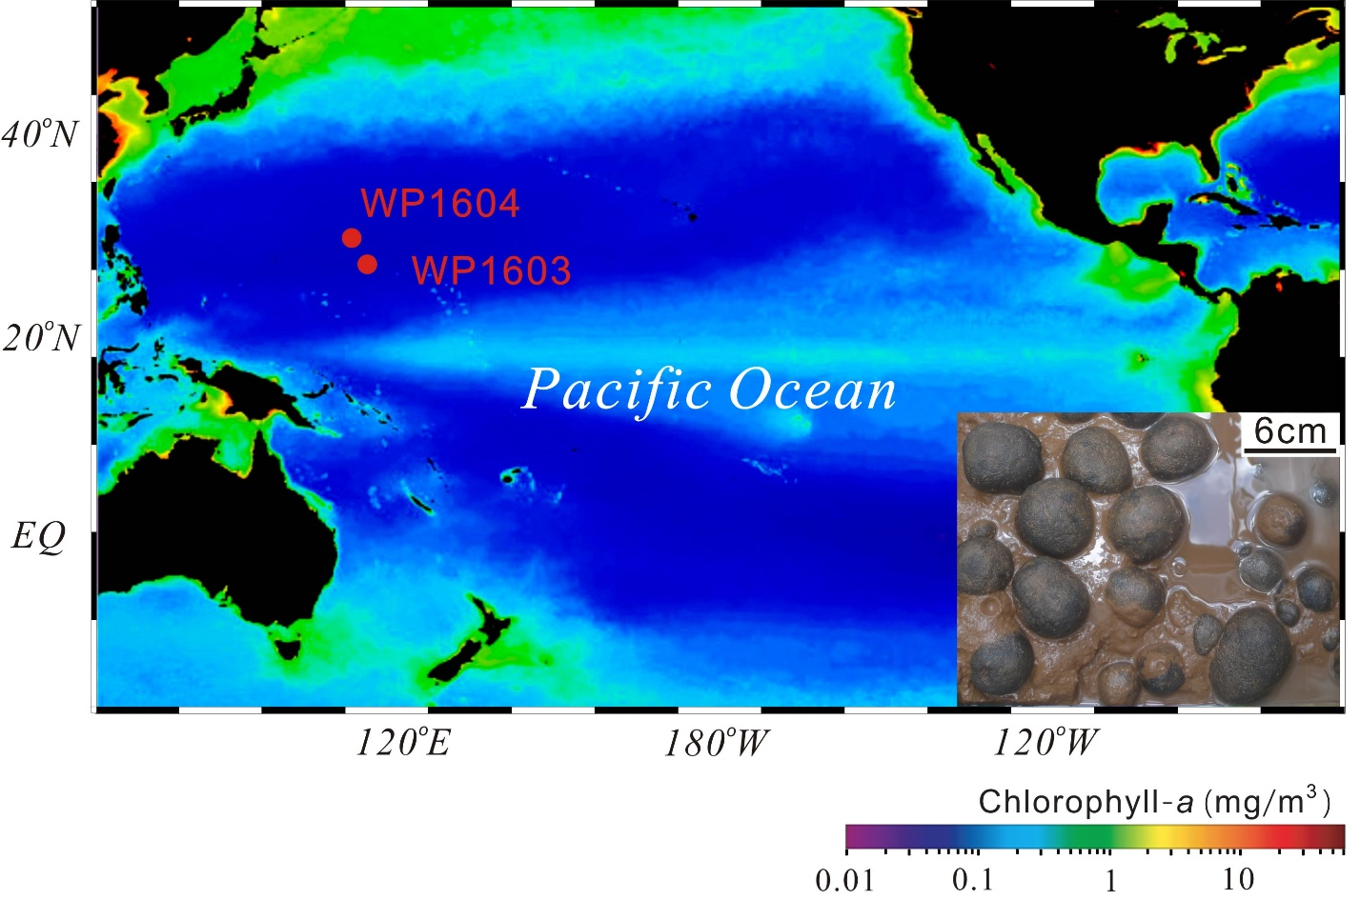
Figure 1. Locations of manganese nodule sampling sites. Surface chlorophyll-a concentrations (average between September 1997 and August 2000) reflecting ocean primary productivity (Behrenfeld & Falkowski, 1997), and locations of manganese nodule sampling sites in the western Pacific Ocean, with image of manganese nodules recovered in a box core of surface sediments.

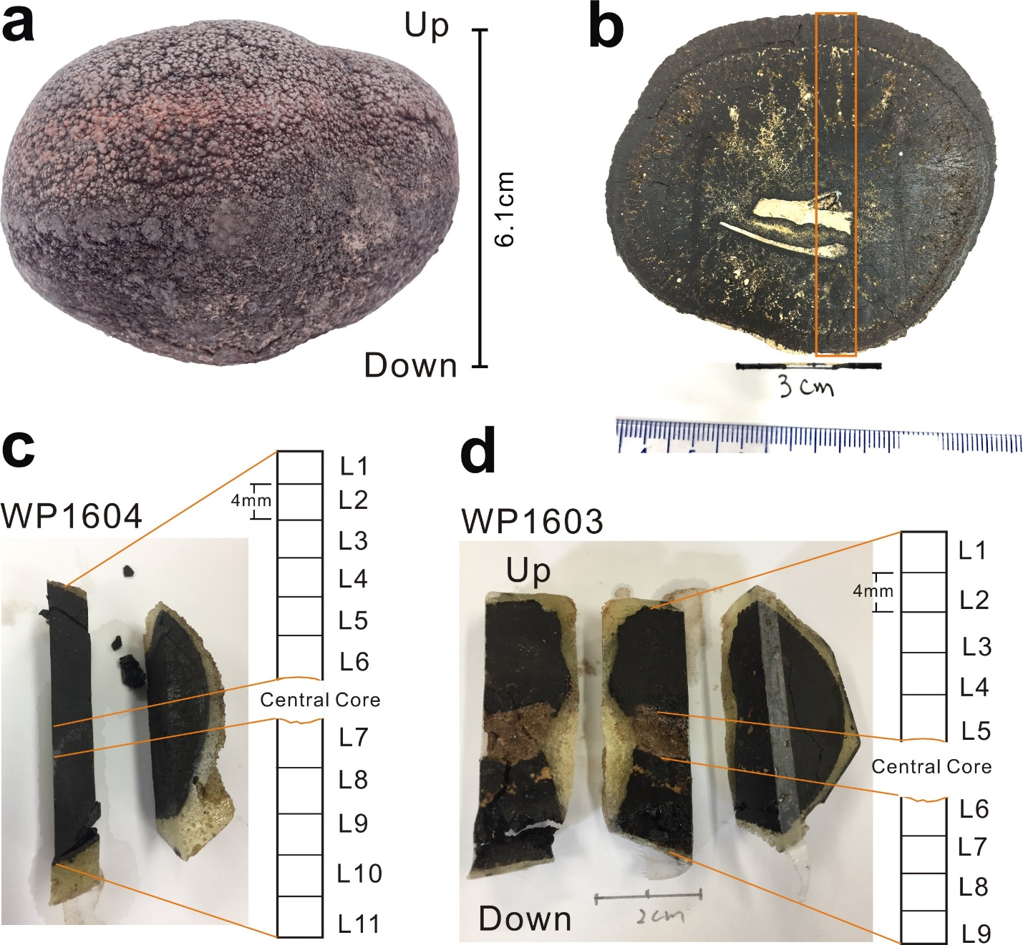
Figure 2. Images of nodule subsamples. (a) Photograph of one of the nodules investigated in this study. (b-d) Subsampling locations in the respective studied nodules.

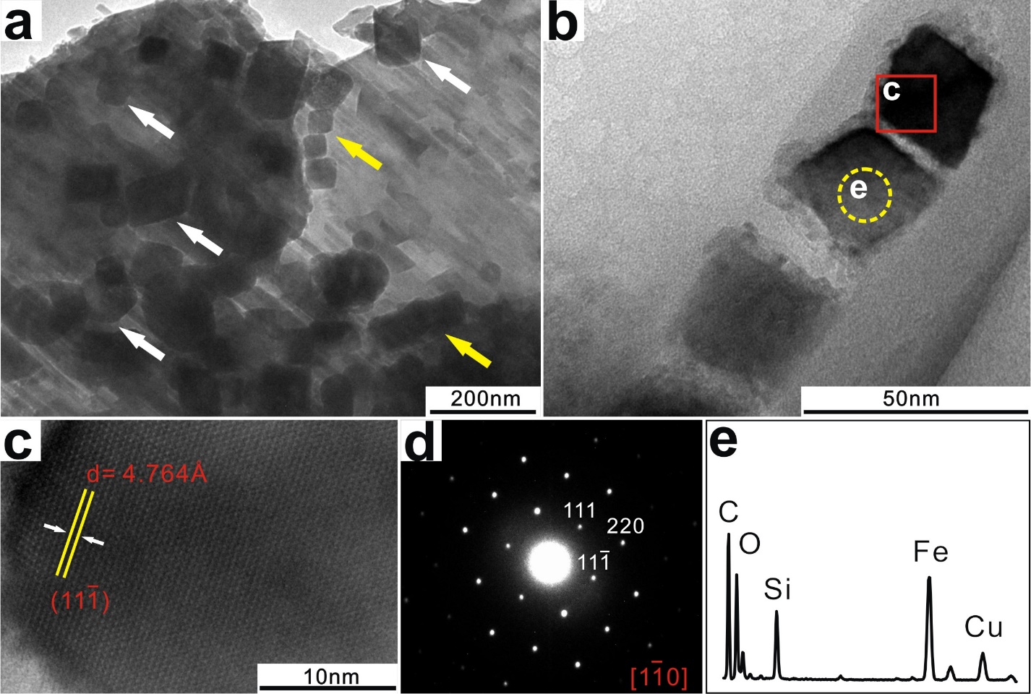
Figure 3. Electron microscope observations of magnetite magnetofossils and MOB fossils. (a-b) TEM images of cubo-octahedral magnetofossils extracted from western Pacific manganese nodules. Yellow arrows in (a) indicate magnetofossil chains, which may have been disrupted in the extraction process, as indicated by white arrows. The red box and yellow circle in (b) indicate the high-resolution and EDS analysis positions, respectively. (c-e) High-resolution image, electron diffraction, and EDS results, respectively. Cu peaks in (e) originate from the TEM grid and C is from the carbon film. The small Si signal originates from large siliceous particles near the analyzed particles.

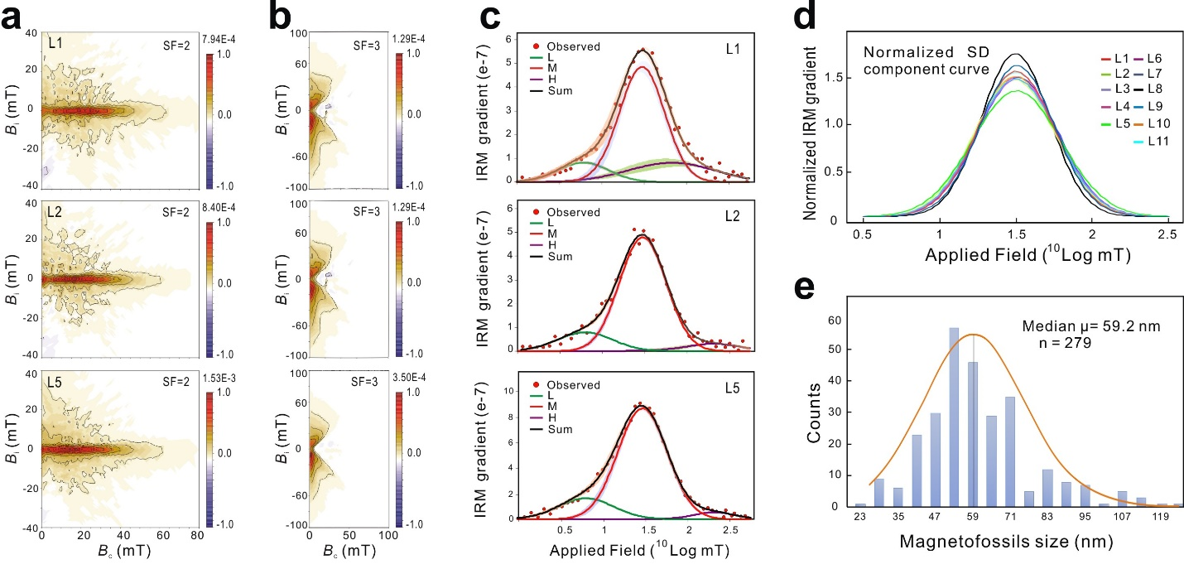
Figure 4. Representative magnetic data and magnetosome size data for the studied nodules. (a) Representative FORC diagrams, which all contain sharp central ridges along the coercivity axis that are indicative of noninteracting uniaxial SD particles, which, coupled with TEM observations in Figure 3, are interpreted to represent intact bacterial magnetite chains. (b) Representative tFORC diagrams, which all have two “wings” along the B_{i} axis that indicate vortex or multi-domain states (Zhao et al., 2017; Roberts et al., 2017) (i.e., the low-coercivity IRM component). (c) IRM component analyses of specimens subjected to FORC measurements. Squares represent data points that deﬁne IRM acquisition curve gradients, which are described by the sum (black) of low- (L, green), medium- (M, red), and high-coercivity (H, purple) components; the M component represents magnetofossils; colored shading for each component indicates the respective 95% confidence range. (d) Normalized intermediate-coercivity curve from different sample slices. (e) Distribution of magnetofossil sizes within the nodule.

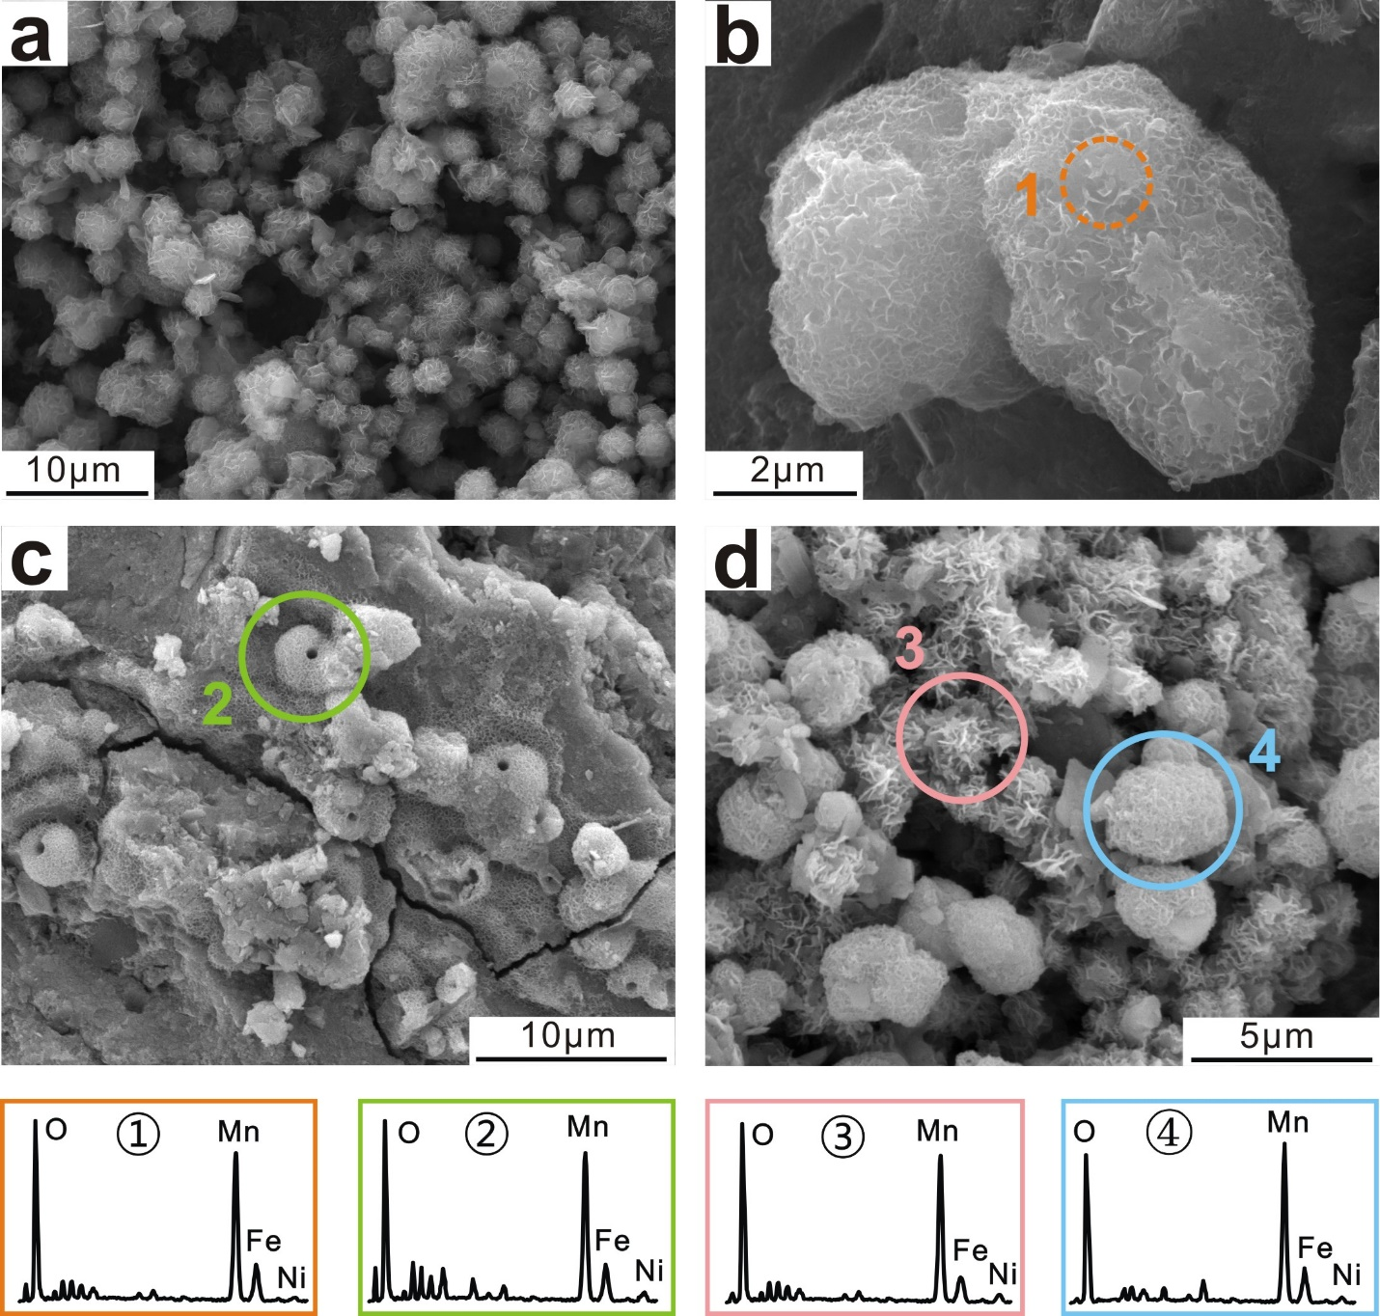
Figure 5. Scanning electron microscope (SEM) images of MOB fossils within nodules. (a-d) MOB fossils with different morphologies were observed in the studied nodules. Circles indicate EDS analysis positions. Small Ni contents are common in MOB fossils.

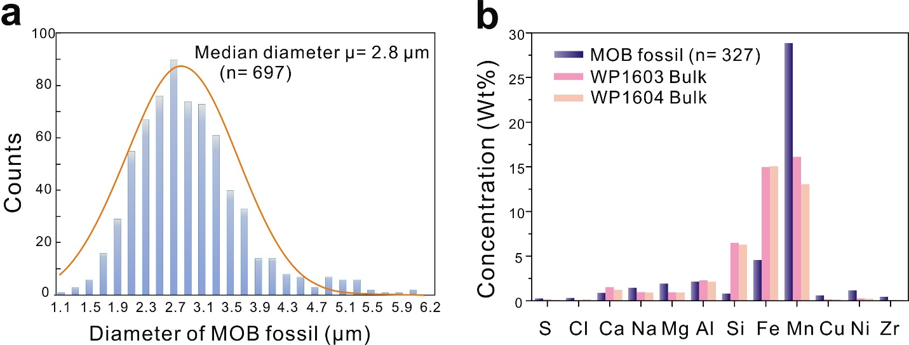
Figure 6. MOB fossil size distributions and elemental compositions of MOB fossils and bulk nodules. (a) Histogram of MOB fossil size distributions in the studied manganese nodules. (b) Histogram of major element compositions of the studied MOB fossils and bulk nodules.

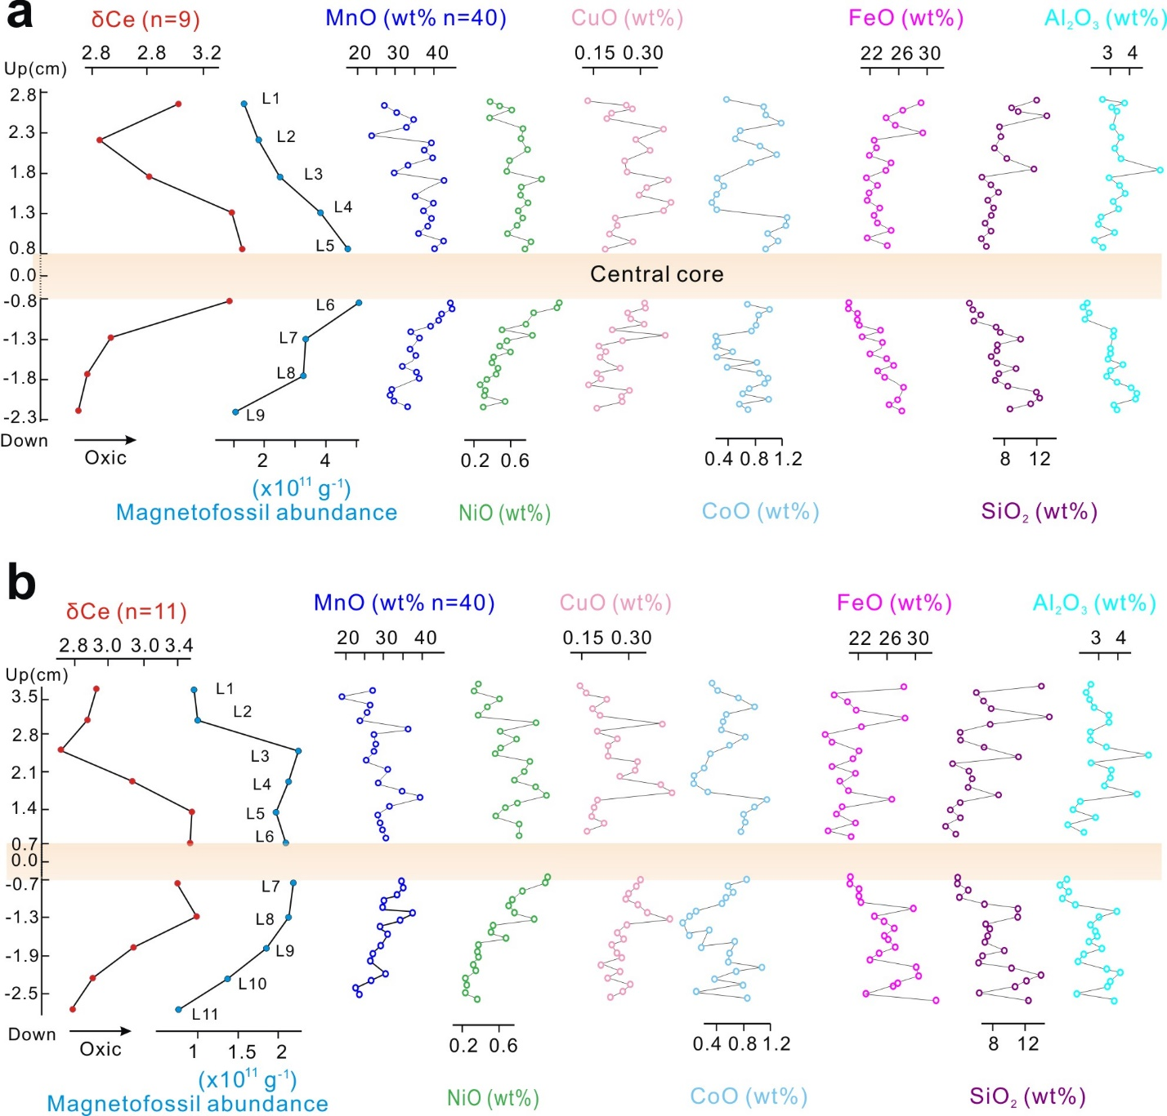
Figure 7. Magnetofossil density, elemental distributions, and oxic-anoxic proxy (δCe) across the studied nodules. Redox condition variations are consistent with magnetofossil densities, and with major metallic element (Mn, Cu, Ni, and Co) variations rather than detrital source variations indicated by Si and Al during nodule formation. Data are for studied nodules (a) WP1603 and (b) WP1604, respectively.

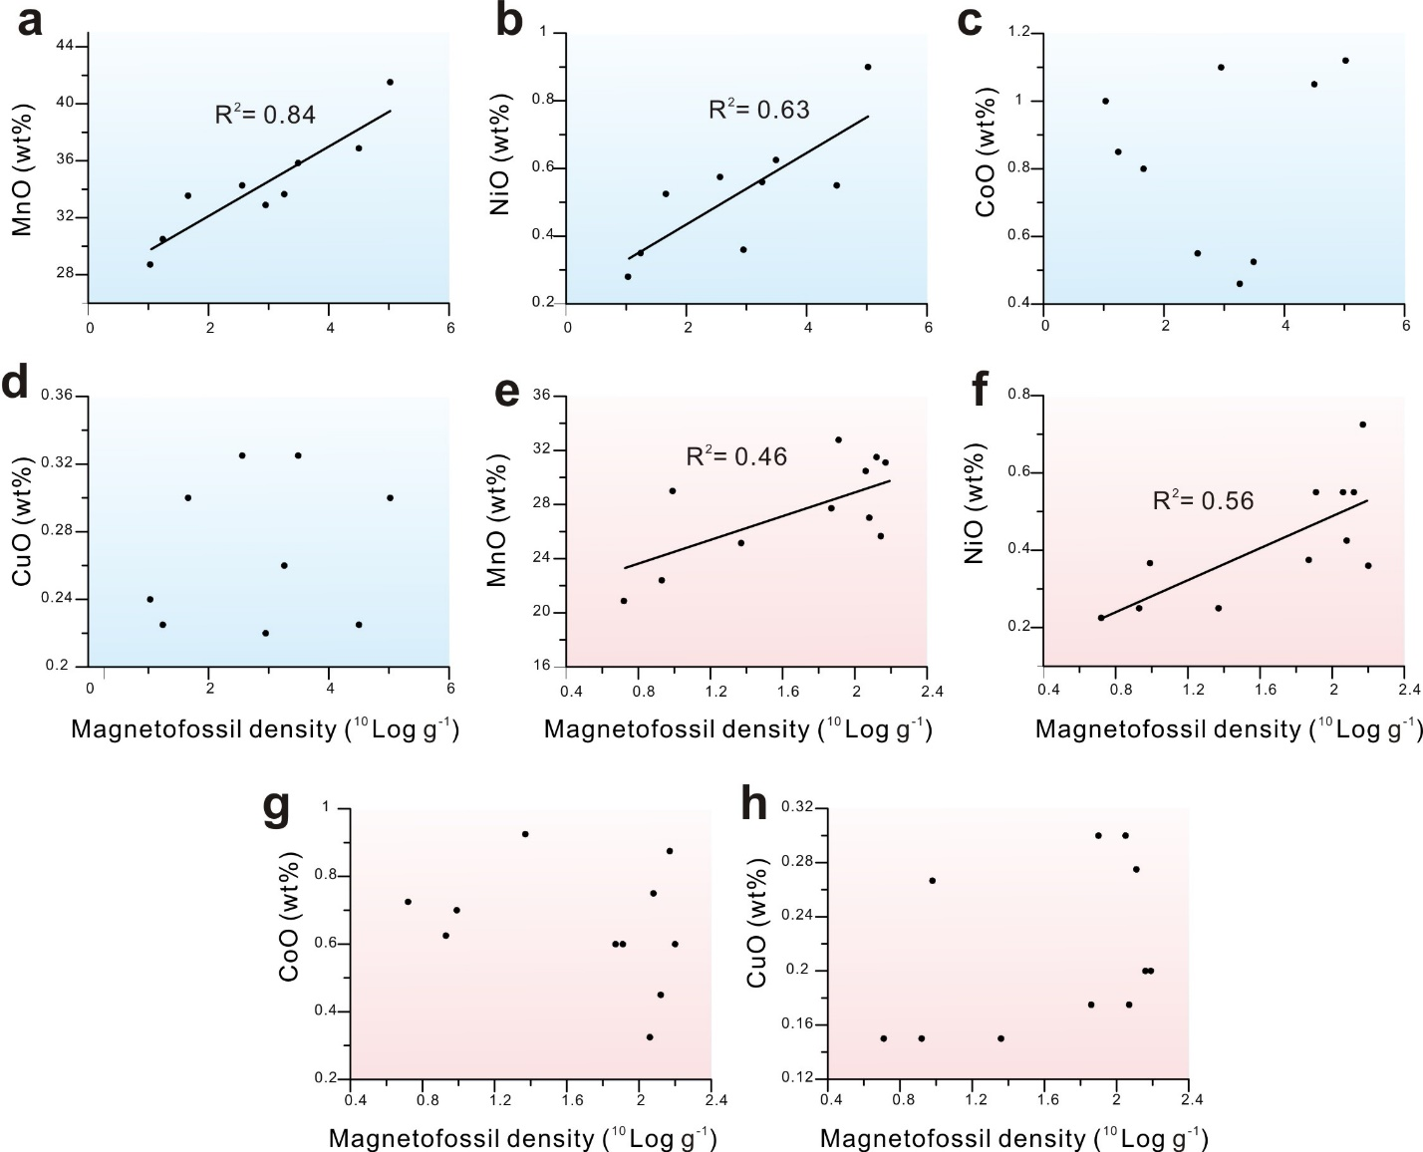
Figure 8. The scatter diagrams of magnetofossil density vs elements in nodules. (a-h) Mn and Ni have better correlation with microbial density than other elements in nodules (light blue and pink indicate the analyzed nodules WP1603 and WP1604, respectively).

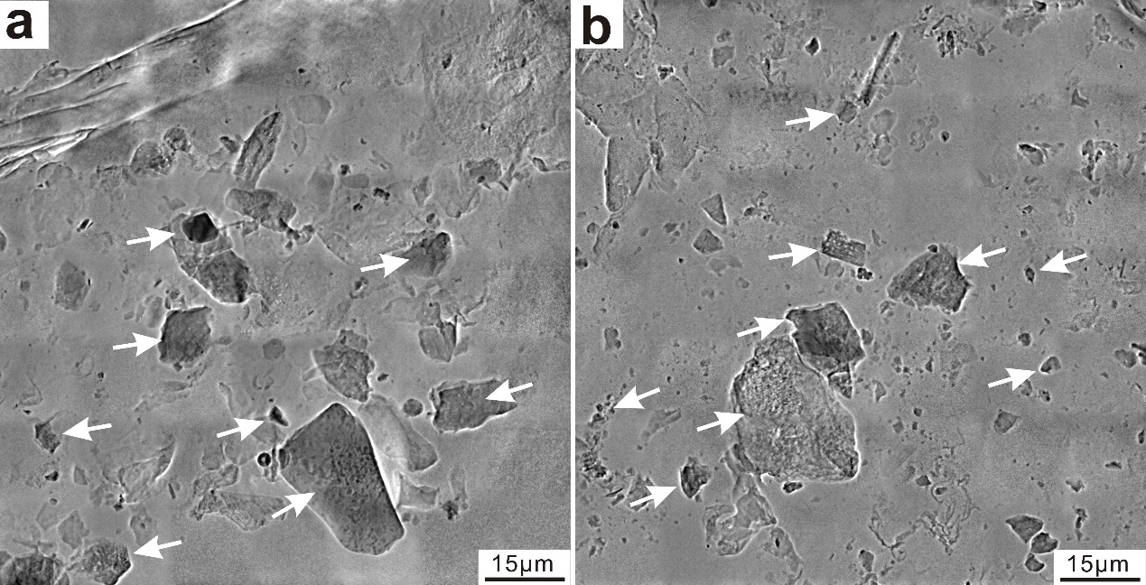
Figure S1. Images obtained using synchrotron transmission X-ray microscopy (TXM) for magnetically extracted particles from nodules. Micrometer-scale (0.3-30 μm) detrital particles are incorporated within the nodule (white arrows indicate the magnetic particles).

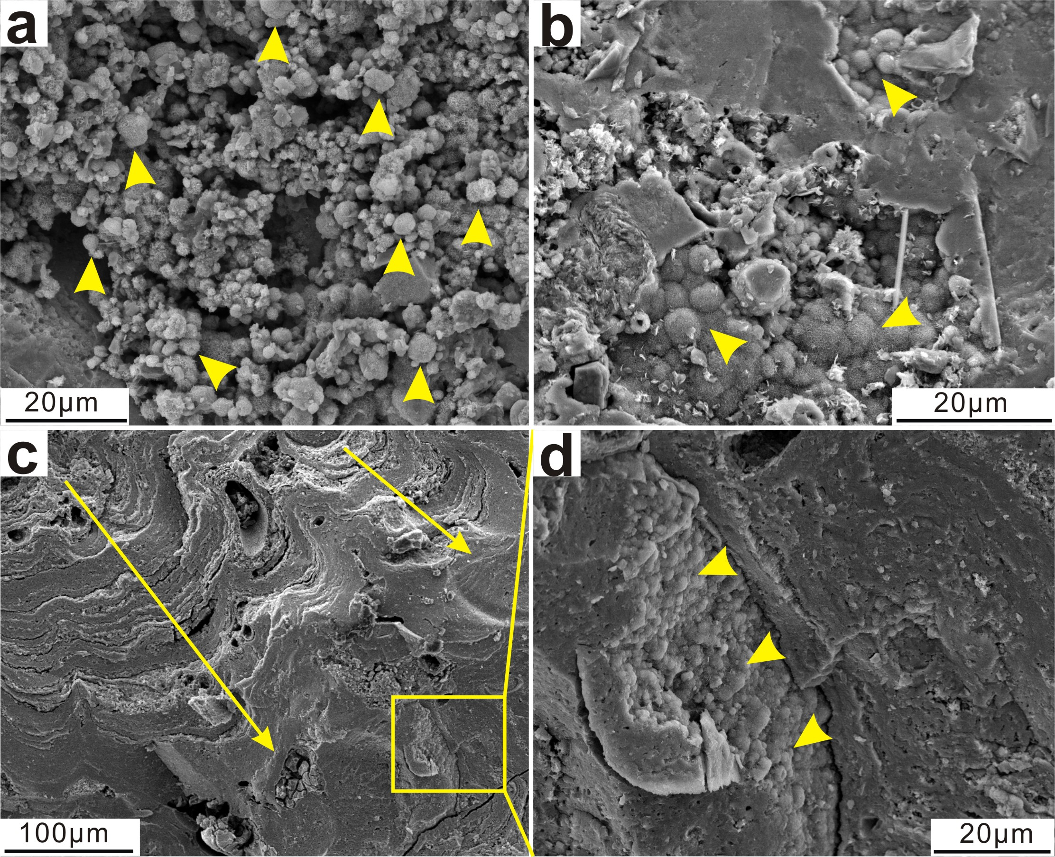
Figure S2. SEM images of MOB fossils and structures inside manganese nodule WP1603. (a) Abundant spheroidal MOB fossils observed in nodules. (b) Agminated spheroidal MOB fossils. (c-d) Some stromatolitic structures in the nodules are composed of agminated spheroidal MOB fossils (yellow triangle and arrows indicate MOB fossils and the growth direction of the stromatolite structure).
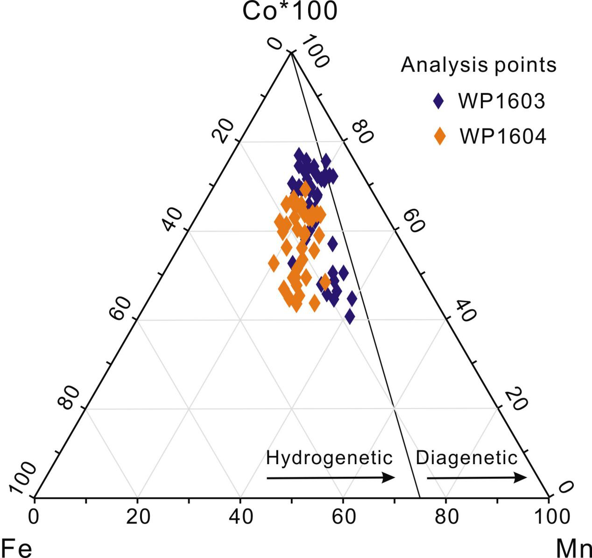
Figure S3. Ternary diagram of Fe-Mn-Co*100 for the studied nodules. Electron probe microanalysis (EPMA) data for the studied western Pacific Ocean nodules (Table S3) are indicative of a hydrogenetic growth mechanism (Halbach et al., 1981; Guan et al., 2017b).

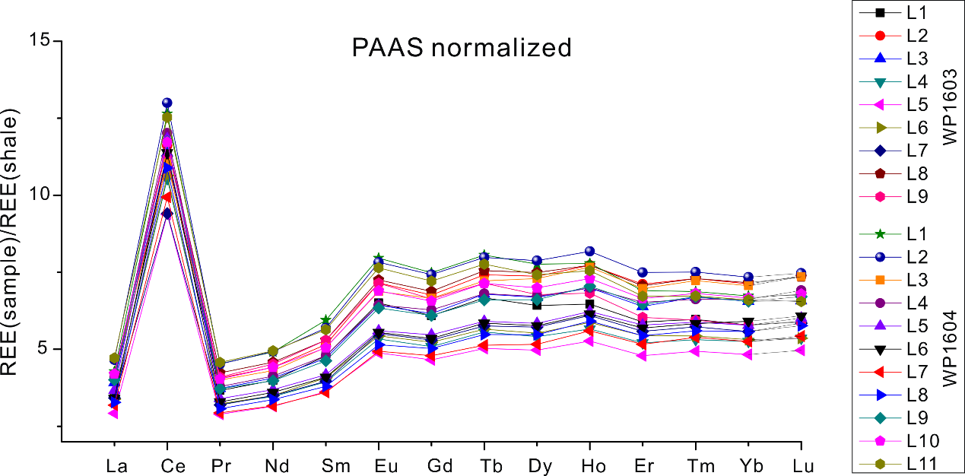

Figure S4. Post-Archean Australian Shale (PAAS) normalized rare earth element (REE) pattern of nodule slices. The strong positive Ce anomalies indicate an oxic environment throughout the time durations over which the studied nodules formed (Pourmand et al., 2012; Guan et al., 2017b).

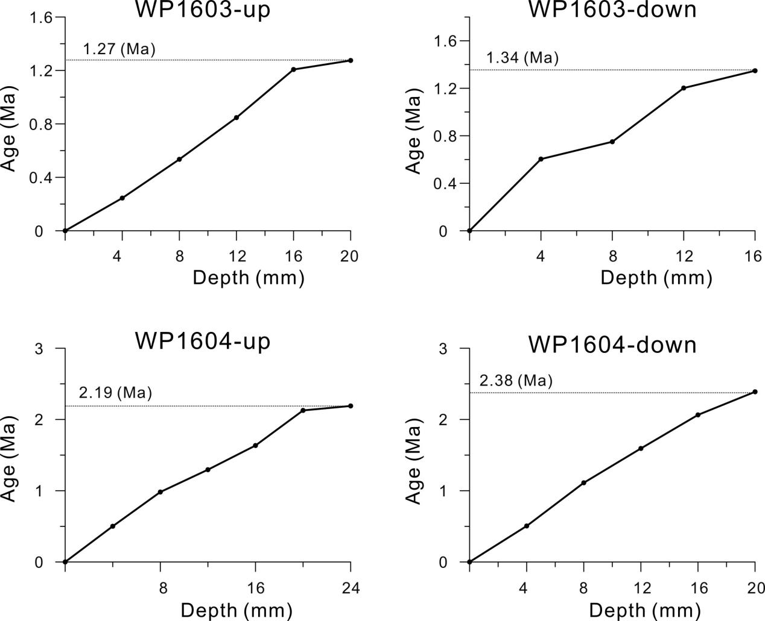
Figure S5. Estimated growth rates and ages of nodules based on Co chronology.

Table 1. Sample information and estimated total biogenic manganese oxide volume.
Nodule  ID | Water depth  (m) | Dry weight (g) | Density  (g/cm³) | Volume  (cm³) | Central core  density (g/cm³) | Central core  volume (cm³)
WP1603 | 5123 | 126.5 | 1.61 | 78.6 | 1.82 | 1.9
WP1604 | 5031 | 209.5 | 1.87 | 112 | 1.91 | 1.15

Table 2. IRM acquisition curve decomposition results.
Samples | M (Am²)  ×10⁻⁷ | Std dev. (Am²)×10⁻⁹ | B_{1/2} | L (Am²)  ×10⁻⁸ | Std dev. (Am²)×10⁻⁹ | H (Am²)  ×10⁻⁸ | Std dev. (Am²)×10⁻⁹
WP1603-L1 | 1.51 | 9.20 | 30.8 | 2.60 | 3.99 | 1.70 | 9.00
WP1603-L2 | 2.34 | 4.88 | 31.8 | 4.09 | 4.26 | 1.50 | 6.00
WP1603-L3 | 3.50 | 8.80 | 29.9 | 7.07 | 3.32 | 1.85 | 9.12
WP1603-L4 | 4.93 | 11.8 | 30.4 | 9.39 | 4.23 | 2.63 | 12.6
WP1603-L5 | 6.19 | 21.6 | 31.9 | 11.9 | 5.05 | 4.05 | 22.7
WP1603-L6 | 6.99 | 5.62 | 28.5 | 15.7 | 4.12 | 3.02 | 8.95
WP1603-L7 | 4.60 | 3.87 | 30.5 | 8.08 | 4.74 | 1.34 | 2.25
WP1603-L8 | 3.71 | 15.2 | 29.8 | 8.36 | 5.30 | 3.10 | 14.7
WP1603-L9 | 1.27 | 10.2 | 29.3 | 2.50 | 3.86 | 2.09 | 7.34
WP1604-L1 | 3.23 | 18.7 | 30.7 | 6.09 | 3.08 | 10.2 | 18.7
WP1604-L2 | 3.30 | 4.42 | 30.1 | 6.45 | 2.95 | 2.54 | 4.99
WP1604-L3 | 7.25 | 4.02 | 30.4 | 17.8 | 4.12 | 3.25 | 2.97
WP1604-L4 | 7.34 | 15.7 | 30.1 | 14.9 | 4.11 | 4.89 | 15.8
WP1604-L5 | 6.31 | 4.20 | 29.3 | 13.4 | 4.80 | 3.32 | 4.25
WP1604-L6 | 7.35 | 4.32 | 30.6 | 14.5 | 4.11 | 2.98 | 2.66
WP1604-L7 | 6.93 | 3.94 | 29.9 | 15.2 | 4.77 | 2.75 | 2.77
WP1604-L8 | 6.89 | 4.52 | 31.2 | 13.7 | 4.63 | 2.04 | 1.43
WP1604-L9 | 5.98 | 4.74 | 30.6 | 11.4 | 4.15 | 2.41 | 4.67
WP1604-L10 | 4.60 | 3.04 | 30.2 | 8.68 | 2.77 | 2.77 | 2.47
WP1604-L11 | 2.53 | 2.35 | 29.8 | 4.44 | 1.70 | 1.76 | 2.08
Saturation remanent magnetization (M_{rs}) of low- (L), medium- (M), and high-coercivity (H) IRM components; Std dev. = Standard deviation. B_{1/2} represents the B_{cr} of medium -coercivity IRM components.

Table 3. Magnetic parameters and magnetofossil abundances per nodule slice.
Samples | Mass (mg) | DP | Mass normalized M_{s}-SD | Std dev. | Magnetofossil density | Std dev.
Samples | Mass (mg) | DP | ×10⁻⁶ (Am²/g) | ×10⁻⁸ (Am²/g) | ×10¹¹ (g⁻¹) | ×10¹⁰ (g⁻¹)
WP1603-L1 | 51.2 | 0.26 | 2.9 | 17.6 | 1.24 | 5.16
WP1603-L2 | 59.9 | 0.27 | 3.9 | 8.15 | 1.66 | 6.88
WP1603-L3 | 58.1 | 0.28 | 6.01 | 15.1 | 2.56 | 10.6
WP1603-L4 | 60.1 | 0.28 | 8.2 | 19.6 | 3.49 | 14.5
WP1603-L5 | 58.6 | 0.29 | 10.6 | 36.9 | 4.50 | 18.7
WP1603-L6 | 59.3 | 0.27 | 11.8 | 9.47 | 5.02 | 20.8
WP1603-L7 | 60.2 | 0.26 | 7.64 | 6.43 | 3.26 | 13.5
WP1603-L8 | 53.6 | 0.28 | 6.93 | 28.3 | 2.95 | 12.3
WP1603-L9 | 52.4 | 0.27 | 2.43 | 19.4 | 1.03 | 4.35
WP1604-L1 | 147 | 0.28 | 2.19 | 12.7 | 0.93 | 3.90
WP1604-L2 | 142 | 0.28 | 2.31 | 3.1 | 0.98 | 4.07
WP1604-L3 | 140 | 0.28 | 5.17 | 2.87 | 2.20 | 9.11
WP1604-L4 | 151 | 0.29 | 4.85 | 10.4 | 2.06 | 8.54
WP1604-L5 | 140 | 0.28 | 4.49 | 2.99 | 1.91 | 7.91
WP1604-L6 | 151 | 0.29 | 4.88 | 2.87 | 2.08 | 8.60
WP1604-L7 | 136 | 0.27 | 5.08 | 2.89 | 2.17 | 8.95
WP1604-L8 | 139 | 0.28 | 4.97 | 3.26 | 2.12 | 8.75
WP1604-L9 | 136 | 0.28 | 4.39 | 3.48 | 1.87 | 7.73
WP1604-L10 | 143 | 0.27 | 3.21 | 2.12 | 1.37 | 5.65
WP1604-L11 | 150 | 0.26 | 1.68 | 1.56 | 0.72 | 2.96
DP = dispersion parameter, Std dev. = Standard deviation; Magnetite M_{s} = 2 M_{rs} for ideal thermally stable uniaxial SD particles (Stoner & Wohlfarth, 1948). Edge-lengths of octahedral magnetosomes = 59.2 nm, σ = 17.3 nm; Standard magnetofossil volume = 9.78 ×10⁴ nm³ with Std dev. = 4.04 ×10⁴. Magnetofossil density = normalized average M_{s} for SD magnetite/standard magnetofossil volume/magnetite M_{s} (magnetite M_{s} = 4.8 ×10⁵ A/m).

Table 4. Estimates of the total MOB fossil volume in nodules.
Parameter | Unit | WP1603 | Std dev. | WP1604 | Std dev.
Normalized average M_{s}-sd | Am² | 13.4 ×10⁻⁶ | 1.21×10⁻⁶ | 7.86 × 10⁻⁶ | 3.70×10⁻⁷
Edge-lengths of magnetofossils | nm | 59.2 | 17.3 | 59.2 | 17.3
Standard magnetofossil volume | nm³ | 97804 | 40420 | 97804 | 40420
Magnetofossil density | unit/g | 2.86×10¹¹ | 1.21×10¹¹ | 1.67×10¹¹ | 6.96×10¹⁰
Magnetosomes per cell | unit/cell | 20 | 5 | 20 | 5
MTB density | cell/g | 1.43×10¹⁰ | 0.64×10¹⁰ | 8.37×10⁹ | 3.70×10⁹
MOB fossil diameter | μm | 2.80 | 0.7 | 2.80 | 0.7
Standard MOB fossil volume | μm³ | 11.5 | 4.51 | 11.5 | 4.51
MTB/MOB |  | 1:1-1:3 |  | 1:1-1:3
MOB density | cell/g | 1.4×10¹⁰  - 4.3×10¹⁰ | 0.7×10¹⁰  - 2.1×10¹⁰ | 0.8×10¹⁰  2.5×10¹⁰ | 0.4×10¹⁰  1.2×10¹⁰
Total MOB fossil volume  in nodules | cm³ | 20.2-60.6 | 12.7-38.1 | 19.9-59.8 | 12.5-37.4
Nodule parameters are from Table 1. Magnetofossil edge-lengths and MOB diameter both have Gaussian distributions (Figs. 4e, 6a); Std dev. = Standard deviation. Magnetosome number per cell is obtained from: Yamazaki & Shimono (2013), Dong et al. (2016), and Liu et al. (2017). The broad range (1:1-1:3) of MTB to MOB ratios are based on reports of MOB or MTB abundances in seafloor microbial communities (Stein et al., 2001; Wang et al., 2010; Liao et al., 2011; Tully & Heidelberg, 2013; Wu et al., 2013; Zhang et al., 2015; Dong et al., 2016; Liu et al., 2017).

Table S1. Major element composition of MOB (n = 327) and bulk manganese nodules (wt%).
Element | MOB fossils | WP1603 Bulk | WP1604 Bulk
C | 11.3 | － | －
O | 45.2 | － | －
Na | 1.47 | 0.97 | 0.93
Mg | 1.92 | 0.95 | 0.92
Al | 2.15 | 2.29 | 2.14
Si | 0.81 | 6.49 | 6.30
S | 0.28 | 0.10 | 0.09
Cl | 0.33 | 0.03 | 0.17
Ca | 0.90 | 1.54 | 1.22
Mn | 28.9 | 16.1 | 13.1
Fe | 4.55 | 15.0 | 15.1
Cu | 0.61 | 0.16 | 0.14
Ni | 1.18 | 0.28 | 0.24
Zr | 0.46 | 0.05 | 0.05
“－” = No test element, elemental detection limit is 0.1%

Table S2. Vertical distribution of major elements in nodule profiles (from EPMA).
 | WP1603 |  |  |  |  |  |  | WP1604
 | SiO₂ | MnO | Al₂O₃ | FeO | CoO | NiO | CuO | SiO₂ | MnO | Al₂O₃ | FeO | CoO | NiO | CuO
1 | 12.0 | 27.1 | 2.5 | 29.6 | 0.5 | 0.2 | 0.1 | 11.2 | 25.3 | 2.3 | 27.7 | 0.4 | 0.2 | 0.1
2 | 10.7 | 29.7 | 3.8 | 25.8 | 0.9 | 0.3 | 0.3 | 5.8 | 16.1 | 2.1 | 14.0 | 0.5 | 0.2 | 0.1
3 | 8.8 | 33.4 | 3.1 | 22.3 | 0.9 | 0.5 | 0.3 | 6.5 | 24.5 | 2.3 | 16.4 | 0.7 | 0.3 | 0.2
4 | 9.6 | 31.8 | 3.4 | 24.2 | 1.1 | 0.4 | 0.2 | 7.2 | 23.7 | 2.5 | 18.0 | 0.9 | 0.3 | 0.2
5 | 13.3 | 24.4 | 3.3 | 30.0 | 0.6 | 0.2 | 0.2 | 12.2 | 22.5 | 3.1 | 27.6 | 0.6 | 0.2 | 0.2
6 | 7.3 | 37.1 | 3.1 | 19.8 | 0.6 | 0.6 | 0.4 | 7.0 | 35.8 | 3.0 | 19.1 | 0.6 | 0.6 | 0.4
7 | 7.5 | 35.5 | 3.7 | 20.3 | 0.9 | 0.6 | 0.3 | 4.5 | 21.4 | 2.2 | 12.2 | 0.5 | 0.3 | 0.2
8 | 6.6 | 37.2 | 3.2 | 18.7 | 1.1 | 0.7 | 0.3 | 4.6 | 26.1 | 2.3 | 13.1 | 0.8 | 0.5 | 0.2
9 | 8.2 | 32.1 | 3.6 | 23.3 | 0.8 | 0.5 | 0.3 | 6.6 | 25.8 | 2.9 | 18.7 | 0.6 | 0.4 | 0.2
10 | 11.7 | 29.2 | 6.1 | 22.2 | 0.6 | 0.4 | 0.3 | 9.2 | 23.1 | 4.8 | 17.5 | 0.5 | 0.3 | 0.2
11 | 5.0 | 39.6 | 2.9 | 18.1 | 0.4 | 0.8 | 0.4 | 3.7 | 29.4 | 2.2 | 13.4 | 0.3 | 0.6 | 0.3
12 | 6.2 | 36.2 | 3.6 | 20.5 | 0.4 | 0.6 | 0.3 | 5.5 | 32.0 | 3.1 | 18.1 | 0.4 | 0.5 | 0.3
13 | 7.1 | 33.5 | 3.9 | 18.7 | 0.3 | 0.6 | 0.3 | 5.6 | 26.6 | 3.1 | 14.9 | 0.3 | 0.5 | 0.2
14 | 5.8 | 37.5 | 3.2 | 18.3 | 0.3 | 0.7 | 0.4 | 5.2 | 33.9 | 2.9 | 16.5 | 0.3 | 0.6 | 0.4
15 | 6.5 | 35.4 | 3.5 | 20.9 | 0.3 | 0.6 | 0.4 | 7.8 | 42.7 | 4.2 | 25.2 | 0.4 | 0.7 | 0.4
16 | 6.2 | 37.0 | 2.4 | 19.7 | 1.2 | 0.6 | 0.2 | 4.9 | 29.0 | 1.9 | 15.4 | 0.9 | 0.5 | 0.2
17 | 5.4 | 36.1 | 2.2 | 20.4 | 1.2 | 0.5 | 0.2 | 3.8 | 25.5 | 1.6 | 14.4 | 0.8 | 0.4 | 0.2
18 | 6.2 | 34.3 | 3.3 | 23.3 | 1.0 | 0.4 | 0.2 | 4.7 | 26.4 | 2.5 | 18.0 | 0.7 | 0.3 | 0.2
19 | 4.9 | 39.5 | 2.0 | 18.3 | 1.1 | 0.7 | 0.3 | 3.4 | 27.5 | 1.4 | 12.8 | 0.8 | 0.5 | 0.2
20 | 5.6 | 37.6 | 2.6 | 22.5 | 0.9 | 0.6 | 0.2 | 4.2 | 28.7 | 2.0 | 17.2 | 0.7 | 0.5 | 0.1
21 | 3.4 | 43.6 | 1.6 | 13.3 | 1.3 | 1.1 | 0.3 | 2.6 | 33.3 | 1.2 | 10.2 | 1.0 | 0.9 | 0.2
22 | 3.8 | 44.0 | 1.3 | 13.0 | 1.1 | 1.1 | 0.3 | 2.7 | 30.7 | 0.9 | 9.1 | 0.8 | 0.8 | 0.2
23 | 4.9 | 41.4 | 1.7 | 15.9 | 1.1 | 0.8 | 0.3 | 3.7 | 31.9 | 1.3 | 12.3 | 0.9 | 0.6 | 0.2
24 | 4.0 | 40.4 | 1.4 | 15.7 | 1.1 | 0.8 | 0.3 | 2.8 | 28.5 | 1.0 | 11.1 | 0.8 | 0.6 | 0.2
25 | 6.8 | 38.2 | 2.3 | 16.2 | 1.0 | 0.7 | 0.3 | 5.0 | 27.9 | 1.7 | 11.8 | 0.7 | 0.5 | 0.2
26 | 7.4 | 32.7 | 3.2 | 22.3 | 0.4 | 0.5 | 0.2 | 9.0 | 39.4 | 3.9 | 26.9 | 0.4 | 0.6 | 0.3
27 | 10.1 | 35.1 | 3.2 | 17.0 | 0.4 | 0.8 | 0.4 | 9.1 | 31.7 | 2.9 | 15.4 | 0.4 | 0.7 | 0.4
28 | 7.0 | 34.0 | 3.1 | 22.6 | 0.4 | 0.5 | 0.3 | 5.6 | 27.0 | 2.4 | 17.9 | 0.3 | 0.4 | 0.2
29 | 7.0 | 32.5 | 3.0 | 22.3 | 0.7 | 0.4 | 0.2 | 6.1 | 28.7 | 2.6 | 19.7 | 0.6 | 0.4 | 0.2
30 | 6.2 | 34.0 | 3.0 | 19.2 | 0.4 | 0.6 | 0.2 | 5.7 | 31.4 | 2.8 | 17.8 | 0.4 | 0.5 | 0.2
31 | 6.9 | 33.4 | 2.9 | 24.0 | 1.1 | 0.4 | 0.2 | 5.5 | 26.4 | 2.3 | 18.9 | 0.9 | 0.3 | 0.1
32 | 9.4 | 30.4 | 3.7 | 25.7 | 0.6 | 0.3 | 0.2 | 7.5 | 24.4 | 3.0 | 20.6 | 0.5 | 0.3 | 0.2
33 | 7.1 | 34.3 | 2.9 | 21.3 | 1.2 | 0.4 | 0.3 | 5.0 | 24.0 | 2.1 | 14.9 | 0.8 | 0.3 | 0.2
34 | 6.7 | 35.1 | 2.7 | 23.2 | 1.3 | 0.4 | 0.2 | 4.1 | 21.1 | 1.7 | 14.0 | 0.8 | 0.2 | 0.1
35 | 8.3 | 31.3 | 3.4 | 26.3 | 1.3 | 0.3 | 0.2 | 8.0 | 30.2 | 3.2 | 25.4 | 1.2 | 0.3 | 0.2
36 | 12.0 | 27.5 | 4.3 | 28.4 | 1.0 | 0.2 | 0.1 | 11.0 | 25.3 | 3.9 | 26.1 | 0.9 | 0.2 | 0.1
37 | 12.4 | 27.1 | 4.6 | 27.8 | 0.9 | 0.3 | 0.3 | 9.2 | 20.2 | 3.4 | 20.7 | 0.6 | 0.2 | 0.2
38 | 11.2 | 28.2 | 4.5 | 26.9 | 1.3 | 0.2 | 0.3 | 8.2 | 20.7 | 3.3 | 19.7 | 1.0 | 0.2 | 0.2
39 | 8.4 | 31.9 | 3.2 | 24.6 | 0.8 | 0.5 | 0.3 | 4.6 | 17.3 | 1.7 | 13.4 | 0.4 | 0.3 | 0.1
40 | 9.5 | 28.9 | 3.4 | 28.0 | 1.0 | 0.2 | 0.2 | 10.2 | 30.9 | 3.6 | 30.0 | 1.0 | 0.2 | 0.2
Elemental detection limit is 0.1%

Table S3. Trace element compositions (ppm) of different slices from the studied nodules (from ICP-MS results).
Samples | La | Ce | Pr | Nd | Sm | Eu | Gd | Tb | Dy | Ho | Er | Tm | Yb | Lu | δCe | Co
WP1603-L1 | 501 | 1214 | 304 | 248 | 169 | 108 | 142 | 125 | 106 | 95 | 86 | 83 | 83 | 78 | 3.01 | 2616
WP1603-L2 | 586 | 1267 | 339 | 275 | 182 | 118 | 158 | 139 | 122 | 113 | 104 | 102 | 103 | 97 | 2.74 | 3553
WP1603-L3 | 563 | 1243 | 310 | 253 | 166 | 106 | 144 | 128 | 111 | 102 | 94 | 93 | 94 | 87 | 2.85 | 3399
WP1603-4 | 486 | 1151 | 268 | 216 | 139 | 88 | 119 | 105 | 89 | 83 | 76 | 74 | 76 | 71 | 3.05 | 3328
WP1603-5 | 419 | 1024 | 241 | 196 | 128 | 81 | 109 | 95 | 82 | 77 | 70 | 69 | 70 | 66 | 3.1 | 3183
WP1603-6 | 486 | 1162 | 269 | 218 | 144 | 90 | 122 | 106 | 91 | 86 | 80 | 76 | 77 | 71 | 3.08 | 4332
WP1603-7 | 492 | 1028 | 266 | 217 | 140 | 91 | 124 | 108 | 95 | 89 | 82 | 80 | 80 | 77 | 2.71 | 2867
WP1603-8 | 603 | 1285 | 352 | 285 | 187 | 120 | 161 | 142 | 124 | 113 | 103 | 102 | 103 | 97 | 2.69 | 3848
WP1603-9 | 583 | 1224 | 341 | 281 | 187 | 118 | 155 | 134 | 112 | 100 | 88 | 83 | 83 | 78 | 2.65 | 2865
WP1604-1 | 615 | 1381 | 377 | 306 | 210 | 132 | 175 | 152 | 128 | 114 | 101 | 96 | 97 | 89 | 2.79 | 2601
WP1604-2 | 670 | 1420 | 376 | 307 | 201 | 129 | 173 | 150 | 130 | 120 | 110 | 105 | 106 | 99 | 2.71 | 3978
WP1604-3 | 586 | 1206 | 333 | 268 | 179 | 114 | 155 | 136 | 121 | 112 | 102 | 101 | 102 | 97 | 2.63 | 3484
WP1604-4 | 590 | 1313 | 315 | 257 | 169 | 106 | 146 | 128 | 111 | 103 | 96 | 92 | 95 | 91 | 2.9 | 3404
WP1604-5 | 527 | 1293 | 283 | 230 | 147 | 93 | 128 | 111 | 97 | 91 | 85 | 82 | 83 | 79 | 3.19 | 3938
WP1604-6 | 490 | 1243 | 274 | 224 | 144 | 92 | 125 | 110 | 95 | 90 | 83 | 81 | 85 | 80 | 3.25 | 4004
WP1604-7 | 457 | 1085 | 244 | 197 | 127 | 82 | 112 | 96 | 85 | 82 | 76 | 75 | 76 | 72 | 3.09 | 4017
WP1604-8 | 471 | 1189 | 256 | 209 | 134 | 85 | 117 | 103 | 91 | 87 | 80 | 78 | 80 | 76 | 3.27 | 4340
WP1604-9 | 576 | 1282 | 310 | 247 | 163 | 105 | 142 | 124 | 109 | 103 | 95 | 93 | 95 | 89 | 2.89 | 3941
WP1604-10 | 603 | 1281 | 336 | 275 | 178 | 114 | 153 | 134 | 116 | 107 | 97 | 95 | 96 | 90 | 2.73 | 3908
WP1604-11 | 686 | 1379 | 379 | 309 | 199 | 125 | 165 | 146 | 122 | 110 | 98 | 94 | 95 | 87 | 2.59 | 3437
Elemental detection limit of ICP-MS is 0.1 ppb. δCe =(2Ce_{N}/(La_{N}+Pr_{N})), where N is the PAAS normalization (Piper, 1974).

Table S4. Calculation of nodule age and microbial density in incipient nodules.
Layers | Growth direction | Depth (mm) | Co (wt%) | Growth rate  (mm/Ma) | Each layer age (Ma) | Age (Ma) | Turnover  Times  ×100 | MB density  ×10¹¹ (g-1) | Incipient  MB density  10⁸
1603-L1 |  | 0-4 | 0.26 | 59.3 | 0.07 | 0.07 | 7 | 6.2 | 8.9
1603-L2 | Up | 4-8 | 0.36 | 11.1 | 0.36 | 0.43 | 43 | 8.3 | 1.9
1603-L3 |  | 8-12 | 0.34 | 12.8 | 0.31 | 0.74 | 74 | 12.8 | 1.7
1603-L4 |  | 12-16 | 0.33 | 13.8 | 0.29 | 1.03 | 103 | 17.4 | 1.7
1603-L5 |  | 16-20 | 0.32 | 16.3 | 0.24 | 1.27 | 127 | 22.5 | 1.8
1603-L6 |  | 12-16 | 0.43 | 6.6 | 0.6 | 1.35 | 135 | 25.1 | 1.9
1603-L7 |  | 8-12 | 0.29 | 27.4 | 0.15 | 0.75 | 75 | 16.3 | 2.2
1603-L8 |  | 4-8 | 0.38 | 8.8 | 0.45 | 0.60 | 60 | 14.7 | 2.5
1603-L9 | Down | 0-4 | 0.29 | 27.5 | 0.15 | 0.15 | 15 | 5.2 | 3.4
1604-L1 | Up | 0-4 | 0.26 | 63.6 | 0.06 | 0.06 | 6 | 4.5 | 7.8
1604-L2 |  | 4-8 | 0.40 | 8.1 | 0.49 | 0.55 | 55 | 4.9 | 0.9
1604-L3 |  | 8-12 | 0.35 | 11.8 | 0.34 | 0.89 | 89 | 11.0 | 1.2
1604-L4 |  | 12-16 | 0.34 | 12.7 | 0.31 | 1.20 | 120 | 10.3 | 0.9
1604-L5 |  | 16-20 | 0.39 | 8.3 | 0.48 | 1.68 | 168 | 9.6 | 0.6
1604-L6 |  | 20-24 | 0.40 | 7.9 | 0.5 | 2.18 | 218 | 10.4 | 0.5
1604-L7 |  | 16-20 | 0.40 | 7.9 | 0.51 | 2.39 | 239 | 10.9 | 0.5
1604-L8 |  | 12-16 | 0.43 | 6.6 | 0.61 | 1.88 | 188 | 10.6 | 0.6
1604-L9 |  | 8-12 | 0.39 | 8.3 | 0.48 | 1.27 | 127 | 9.4 | 0.7
1604-L10 | Down | 4-8 | 0.39 | 8.5 | 0.47 | 0.79 | 79 | 6.9 | 0.9
1604-L11 |  | 0-4 | 0.34 | 12.3 | 0.32 | 0.32 | 32 | 3.6 | 1.1
Co content from Table S1, MB= microbial abundance. Biomass turnover in seafloor environment is approximately 100 years (Santelli et al., 2008).

