The nature, depositional environment and effects of faulting on an alluvial sandstone body, Whitby, North Yorkshire
Matthew Ingham, Department of Earth Sciences, University of Durham
Abstract: The exposed alluvial sandstone body seen in the town of Whitby is part of the Saltwick Formation, which in turn is part of the Ravenscar Group of the Jurassic. The area of study, the West Cliff, is well exposed within the cliff face and is 700-1000m wide, and up to 25m thick. The sediments are of fluvio-deltaic origin and were deposited in the fault bounded Cleveland Basin which governed local sedimentation in the Middle Jurassic. The formation is laterally variable in both character and sedimentary facies, with the Whitby fault playing a crucial role in the development of the sandstone body and its associated facies. Some sections preserve channel storeys whereas others possess isolated bodies with vastly different internal structure. Lithologies range from fine to medium grained sandstone, comprising ~85% by volume, with fine mudstone and siltstones comprising the remainder. The sandstone facies themselves encompass many structures including cross bedding, ripples, and iron rich beds, indicating channel flow variation. In comparison, the fine grained sediments show flaser bedding and bioturbation, likely to be related to periods of deposition and aggradation.

Introduction
Situated on the East Coast in North Yorkshire (Fig.1.), the sediments deposited in the town of Whitby provide a spectacular snapshot of Mid Jurassic depositional cycles and environment.
The multi-storey alluvial sandstone body was deposited in the Aalenian and lies extensively in its palaeoslope direction (N-S). It is a well studied site and comprises mature quartz arenites and sub-arkosic arenites (Kantorowicz 1984, 1990) in channel bodies on the West cliff. Heading Westwards up the coast, a gradual influx of fine grained sediments with contrasting sedimentary structures and facies is observed. Also evident are the effects of both diagenesis and compaction on the sediments, leading to a reduction in porosity and permeability and is linked to the formation of iron rich bands. Further to this, localised precipitation and fluid flow has formed sideritic nodules and in many cases, bands.
The Whitby fault trends N-S and exhibits 12m of offset, downthrown to the West (Hemingway et al. 1968). It is thought it has been active before, during and after the deposition of the Saltwick Formation (Alexander 1986), however the nature and amount of deformation during the deposition of the unit is unknown.
The main aim of this research is to understand how and why the West cliff is as we see it today, especially as the sediments on East cliff differ so greatly in both nature and structure. In order to do this, a risk assessment was carried out, allowing me to make a full, detailed interpretation of the sandstone bodies depositional environment. To allow a quantitative data analysis, a range of field techniques were employed including sketches, photographs, graphic logs and field measurements were taken.

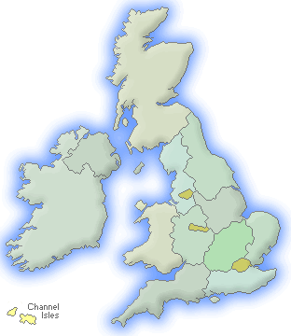
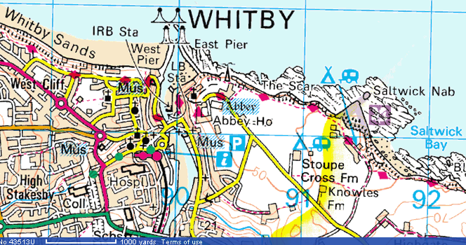

Fig.1. Map showing the location of Whitby. Double ended arrow shows approximate location of study site. Red line trending N-S indicates approximate location of Whitby fault. Red tick indicates downthrown side (West cliff).

Main Results
The alluvial body is composed of three distinct sandstone units (Fig.2.), each with unique sedimentary facies and structure. Each sandstone body is separated by finer grained sediment, reflecting a change in environment and therefore depositional cycles within the Cleveland Basin. A common feature of the Whitby West cliff is the presence of iron rich beds. Some cross cut bedding planes, whereas some follow the planes perfectly. Added to this is presence of siderite nodules. These are formed due to differential fluid flow upon compaction, whereby the siderite diffuses out and often forming polygon like shapes. These therefore represent a post-depositional, secondary diagenetic feature, giving little significance in reconstructing the depositional environment of the sandstone body. The added presence of dissolution seams provides further evidence of early diagenetic processes and pressure dissolution. These features appear to be local to the sandstone body as a whole.
Unit A is the oldest sandstone unit seen at West cliff (Alexander, 1993). It is composed of well sorted and rounded,

medium grained sandstone, and demonstrates features including cross bedding and planar lamination. Numerous types of cross bedding exist within this unit, including herringbone and trough cross beds. These are due to subtle variations in flow within the Cleveland Basin, leading to non-uniform cross beds. Another interesting feature is the presence of overturned cross bedding. There is insufficient evidence to say whether this was formed as a primary depositional feature or formed due to load pressure of overlying sediments, so provides little significance in determining the depositional environment.
Evident within this unit is a channel bar preserved to the East of West cliff. Its position within the sandstone body suggests it maybe a lateral bar, preserved in a body exhibiting waning flow and abandonment features. The gradual transition from uniform, sandstone beds into finer grained sediments in the West may reflect a change in sedimentological deposition, as well as the beginnings of waning flow and channel abandonment. Silt deposition took place as a result of this, before equilibrium, channel conditions took over once again. The
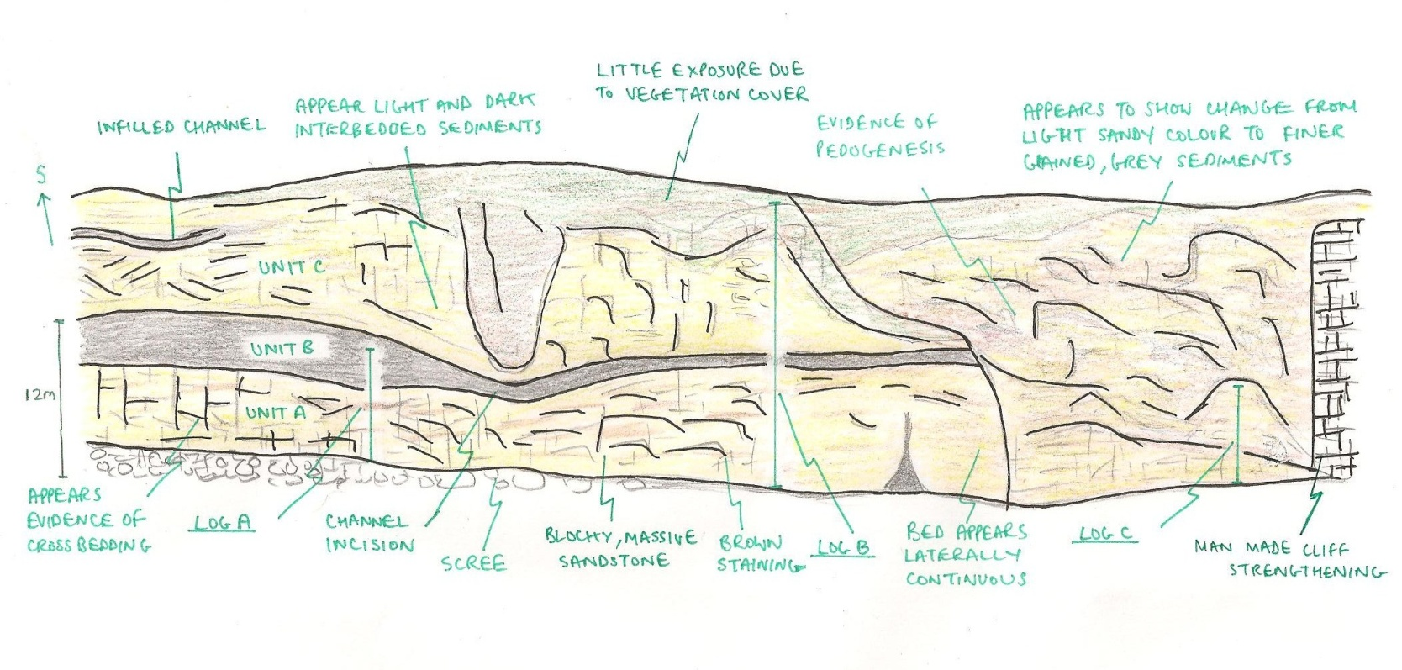
Fig.2. A sketch map of the study site at Whitby West cliff. Shown are initial field observations and interpretations with the relative position of graphic logs.
interbedded nature of the silty mudstone seen in log C reflects waning flow conditions, in turn leading to both flaser and lenticular bedding.
Unit B is grey in colour and varies in thickness from <1m to 7m. Lithologically, it appears to be medium grained sandstone. The contact between units A and B is sharp and undulatory, reflecting a distinct change in depositional cycles. A key structure seen in West cliff is a sharp, down cutting feature into fine sediments of unit A. This represents channel abandonment fill, whereby a river channel was abandoned and deposition of fine sediment fills its former locality. Further evidence for the presence of a river channel in the bodies geological past is provided by the crevasse splay within the unit. This is formed through erosion of a weak point in the banks of a levee. A subsequent reduction in velocity follows, causing coarse sediment to be deposited first, followed by finer sediment further afield and producing pinching out of the splay.

A greater understanding of the sandstone bodies depositional environment comes from the presence of both flaser and lenticular bedding, deposited in between units A and B. Bedding seems to fluctuate greatly in both thickness and intervals, but overall can be classified as finely laminated (Fig. 3). These features are typically formed in tidal environments, whereby sediment is exposed to intermittent flow (Stow, 2005). This leads to alternative layers of sand and mud, whereby mud typically comes out of suspension and is deposited in lenses during periods of slack water. Flaser beds show a predominancy of sand to mud whereas lenticular beds have a greater amount of mud to sand. These beds usually form in a high energy environment. Further understanding of the depositional environment comes from the presence of both scour marks and bioturbation. The scour marks exhibit an irregular surface, cutting into the beds. This may reflect a short term change in sediment flux and current flow. It does

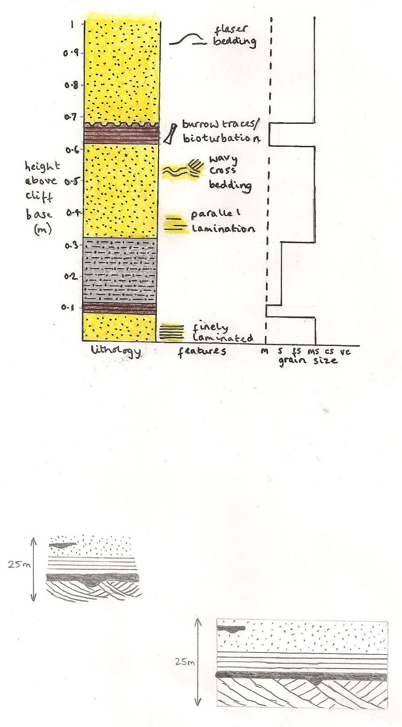
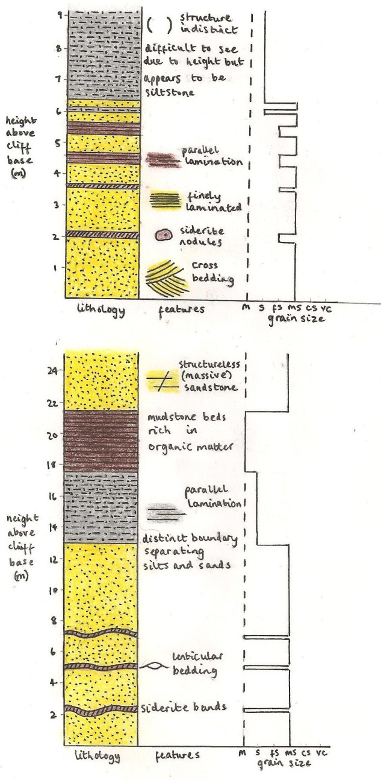
Fig. 3. Representative sedimentary logs from the Whitby West sandstone body. See Fig.2 for relative position of these logs. Evident is the transition from a sandstone dominated body to one of an interbedded, silty mudstone and sandstone sequence. Also recognisable is the change in sedimentary structures.

Log A
however prove that current action played a major role in the bodies depositional history. The presence of sparse bioturbation, known as skolithos, was formed by presumably a worm like organism burrowing into soft sediment and is 5cm in depth. This becomes later in filled, creating the trace fossil seen.
Unit C has a thickness of ~10m and appears to be medium grained, cross bedded sandstone, appearing similar in colour to unit A. However, due to height constraints, a detailed lithological and structural description could not be obtained.
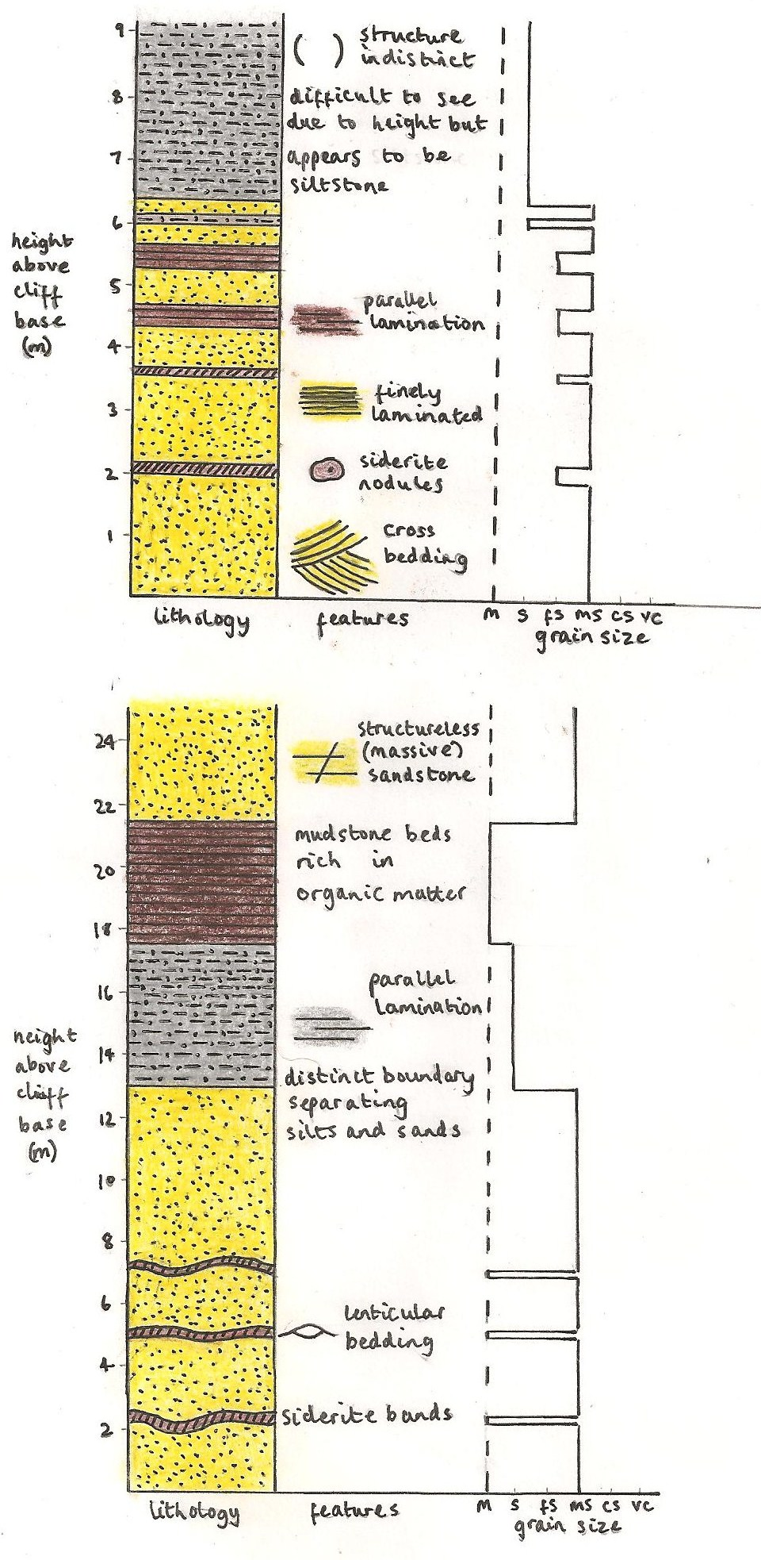
Log C
Log B
Log A

Discussion
The features seen at the site suggests the Cleveland basin experienced regular, minor fluctuations both in current flow and sediment deposition, in turn controlling channel migration, avulsion and aggradation rates respectively. These therefore represent the principal processes controlling the characteristics of the sandstone body (Bridge & Leeder, 1979). It is believed the principal source of sediment was obtained from the Mid North Sea High, and the rose diagrams support this finding (Fig.4.). These palaeocurrent findings also show that the principle flow direction was from the SSE, re-emphasising the flow direction into the Cleveland Basin.
The N-S trending Whitby fault has played a key role in the development of the alluvial sandstone body. Although there is little evidence for the local effects of faulting, e.g. fault breccias, it can be seen that 12m of offset has taken place, downthrown to the South. A basins
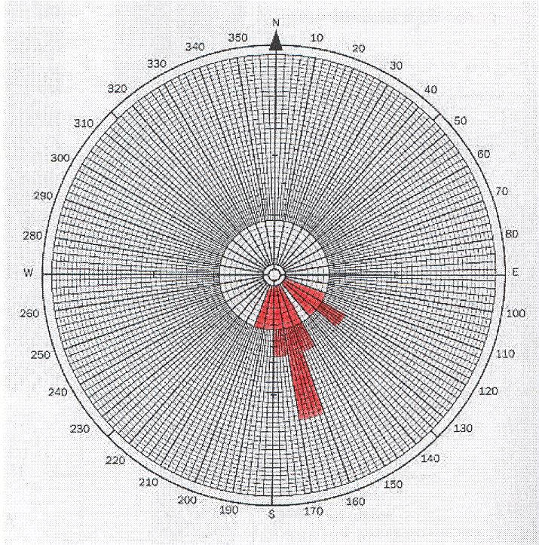
Fig.4. A rose diagram plotting palaeocurrent results for the Whitby West sandstone body. 12 measurements were taken in total. The rose diagram illustrates the source of sediment supply from the Mid North Sea High in the unimodal cluster of measurements seen from the South.

sediment supply is largely dependent upon the local gradient of sites where the sediment is derived, into the basin. This faulting may produce the topography needed for rivers to continually re-occupy the same area, producing both the interbeddedness of some of the units, as well as the massive sandstone body to develop seen at Whitby (Galloway, 1981). This tectonic deformation may provide the reason behind the occurrence of fine grained sediments within unit B, deposited in the hanging wall depression of the Whitby fault. During periods of little tectonic activity, avulsion may occur, leading to channel migration and the subsequent infilling of its former site. This would explain both the location and nature of the infilled channel seen in unit C. It would also explain the reason for evidence of pedogenesis seen in between some of the units. During periods of little sediment accumulation and deposition, time is provided for the development of mature palaeosols seen in parts of West cliff.
The varying styles of bedding previously mentioned (flaser, lenticular and herringbone cross bedding) provide a good insight into the type of flow which affected unit A. These reflect intermittency in flow, related to tectonic uplift created by the Whitby fault. Herringbone cross bedding is formed due to tide coming in and going out, producing cross beds in differing directions to one another.

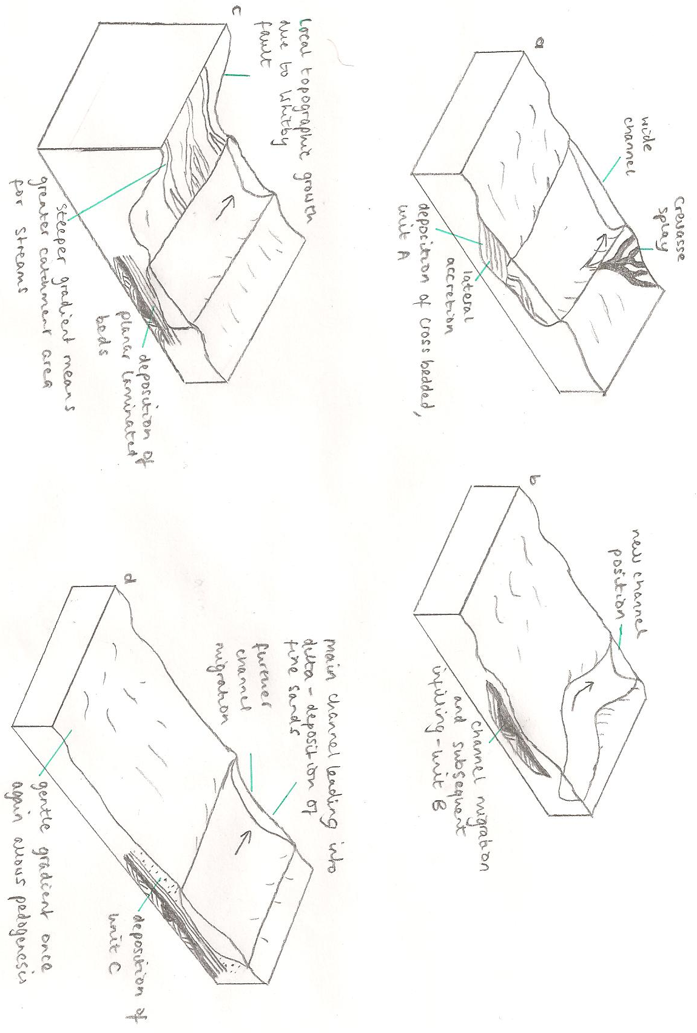
Fig. 5. Block diagrams representing the development and depositional environment of the Whitby West alluvial sandstone body. (a) Deposition of unit A within a wide river channel. Crevasse splay is formed due to river bursting its levee banks (b) Channel has been abandoned, leading to deposition of fine grained sediments and subsequent infill of former channel location (c) Deposition of planar laminated, fine grained alternating muddy sands due to tectonism of Whitby fault (d) Further channel migration. Unit C is deposited in a deltaic environment leading to fine sand deposition. Large amount of organic matter leads to pedogenesis. (e) A cross sectional sketch through the deposited sediments.

a
b

c

d

e

The formation of siderite nodules, iron rich beds and evidence of pedogenesis in these deltaic sediments can be largely contributed to variations in ground water chemistry within its initial depositional environment. The influx of water with a different chemistry whereby the channel meets its mouth may also explain this (Kantorowicz, 1990).

Conclusion
Lithologically, the Whitby West sandstone is composed of three sandstone units, separated and on occasions interbedded with finer grained sediment. The differing units and intervening sediments reflect a change in depositional cycles within the Cleveland basin, both channel characteristics and sediment load.
Throughout its depositional history, the Whitby West sandstone body has undergone many processes which have in turn created the body we see today. Unit A possesses numerous characteristics which suggest a river channel, creating braided stream and channel facies (Fig. 5).
In summary, the Whitby fault has played a major part in the development of the alluvial sandstone body. Movement along the fault created a local topographic high, in turn producing a steeper gradient for rivers to deposit sediment within the Cleveland Basin. In contrast, periods of little or no tectonic activity would allow pedogenesis and the deposition of the finer grained sediment of unit B in the hanging wall of the fault. These processes act while the channel flows down towards the delta plain, providing an explanation for the presence of channel bars exhibiting waning flow and abandonment features. Once the river has reached its mouth, its load is dropped due to a lack of velocity. It is thought that this, combined with tidal currents affecting the delta, led to the deposition of unit C
Although permeability measurements were beyond the scope of this report due to both technological and time constraints, work done by Alexander and Gawthorpe indicate a significant variation in permeability within the sandstone body (ranging from 0.8 to 682.1mD, with a geometric mean of 83.5mD). The cross bedded sandstone generally exhibits greater permeability than other units. This range is probably due to variations in diagenesis, grain size and sorting. This permeability variation means that the Whitby sandstone body may possess properties of an aquifer. Another crucial point worth noting is the fact that the sandstones of the study site possess properties of a reservoir rock for oil. It is thought that the sandstone body may extend throughout for miles throughout the North Sea, therefore acting as an analogy for North Sea oil exploration. This is also the case for the potential aquiferic properties of the Whitby West sandstone. This provides an opportunity for economic rewards to be reaped from an, at first glance, simple alluvial fan sandstone body.
References

http://www.multimap.com

http://www.trchairs.co.uk/web/web/page8_files/map-great-britain.gif

Notes made in the field by myself

Photographs taken by Jamie Foster and Ollie Stoten in the field- used to help write report.

Palaeocurrent data was collaborated with Ollie Stoten for a greater range of data and more reliable result

ALEXANDER, J. 1986. Idealised flow models to predict
alluvial sandstone body distribution in the Middle
Jurassic Yorkshire Basin. Marine and Petroleum
Geology, 3, 298-305.
ALEXANDER, J & GAWTHORPE, R. L. 1993. The complex nature of a Jurassic multistorey, alluvial sandstone body, Whitby, North Yorkshire. Geological Society, London, Special Publications 1993; v. 73; p. 123-142.

BRIDGE, J. S. & LEEDER, M. R. 1979. A simulation
model of alluvial stratigraphy. Sedimentology, 26,
617-644.
GALLOWAY, W. E. 1981. Depositional architecture of
Cenozoic Gulf Coastal Plain fluvial systems. In:
ETHRIDGE F. G. & FLORES R. M. (eds) Recent and
ancient nonmarine depositional environments.
SEPM Special Publication, 31, 127-156.
HEMINGWAY, J. E., WILSON, V. & WRIGHT, C. W. 1968.Geology of the Yorkshire Coast. Geologists'Association Guides 34, Benham, Colchester.
KANTOROWICZ, J. D. 1984. The nature, origin and
distribution of authigenic clay minerals from
Middle Jurassic Ravenscar and Brent Group
sandstones. Clay Minerals, 19, 359-375.

KANTOROWICZ, J.D. 1990. Lateral and vertical variations in pedogenesis and other early diagenetic phenomena, Middle Jurassic Ravenscar Group, Yorkshire. Proceedings of the Yorkshire Geological Society, 48(part 1), 61-74.

STOW, D.A.V. 2005. Sedimentary rocks in the field- A colour guide. Manson publishing.

