Community structure, environment and primary ecological controls on the Wenlock Limestone fauna
Matthew Ingham, Department of Earth Sciences, University of Durham.
Working on sample SL99 with Jamie Foster, Katie Carruthers and Ahmad Mitoubsi.
Abstract: The Wenlock limestone was deposited in the Mid-Silurian when Britain was situated in an equatorial region, thus having major implications for both the species present and their subsequent modes of life. Following the Late-Ordovician mass extinction, major biota re-structuring took place, reflecting an ecological recovery for all life forms and in turn restoring equilibrium to shallow seas. Many species were forced to adapt and modify their mode of life to become more efficient, for example brachiopods increased the size of the feeding lophophore.
Many ecological factors control the nature of the assemblage seen, including depth, salinity and pressure. The sub-littoral zone was teeming with life, leading to a margalef diversity value of 4.23. As a result of the relatively high energy environment, many species exhibit disarticulation and fragmentation, whereas some are well preserved due to rapid burial. It is believed some species are allochthonous and exhibit the effects of thanatocoenesis, however many remain local to their original habitat forming a neighbourhood assemblage. Brachiopods form the trophic nucleus within the suspension feeding food chain, making up 55% of the total species seen.
Introduction

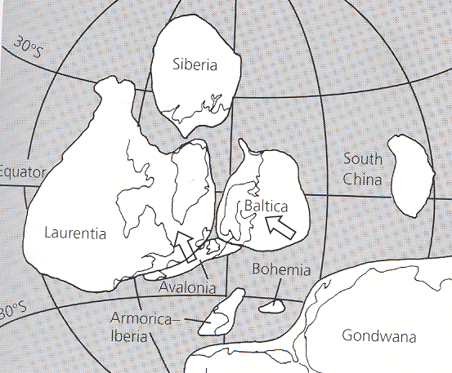
The Wenlock limestone is one of the most studied fossil assemblages in Britain. Deposited during the mid-Silurian (428-423Ma), parts of Britain were on both Laurentia and Avalonia, and Britain was situated slightly South of the equator. (Fig.1). This had major implications for the ecology, environment and therefore fauna and species which were able to adapt to and accommodate such an environment.
The early-mid Silurian represented a time of ecologic recovery and resurgence of reef biota following the Late-Ordovician glaciation event (Watkins, 2000). 85% of species became extinct, including many reefs, brachiopods and trilobites. Although no major re-structuring of the marine biosphere occurred, diversity on marine continental shelves was undoubtedly altered.
The aim of this investigation is to gain an insight into the environment, community structure and controls on the Wenlock limestone fauna. This will allow analysis of the different organisms and their relative modes of life. On a global scale, diversity changes with latitude, being highest in tropical regions and decreasing pole ward. This provides an example of a species-area effect (Brenchley and Harper, 1998). It is expected that the assemblage will display moderate diversity and a dominance of certain species which became adapted to its environment quicker and more effectively than its competitors. Life in shallow marine, sub-tropical latitudes was light rich due to its position near the equator. However, it was probably oligotrophic (nutrient poor). A typical Palaeozoic environment would therefore display a limited amount of guilds and be rich in suspension feeding organisms. This suggests that the trophic nucleus may be brachiopod dominated.
Fig.1. Palaeocontinental reconstruction for mid-Silurian time, during which the Wenlock limestone was deposited. The arrows on Baltica and Avalonia show their directions of movement until this time (Woodcock and Strachan, 2000).
Material and Methods
The assemblage of sample SL99 was taken from the Wenlock Limestone Formation near Dudley in the West Midlands. The sample itself displays a range of specimens, some well preserved due to rapid burial and some which are damaged and disarticulated. It is difficult to distinguish whether this is due to compaction and diagenesis during burial or whether this was a primary occurrence upon deposition or when the organism was living.
All specimens were sorted to species level and counted. Due to the high degree of fragmentation of many of the specimens, it is difficult to know whether fragmented parts constitute another specimen or part of a specimen which may have already been counted. This provides a significant error envelope, as it is almost impossible to tell whether, for example, part of a crinoids ossicle belongs to one previously counted. The number of brachiopod “individuals” for a species was calculated as articulated shells plus maximum number of either brachial or pedicle valves. All measurements were taken from whole specimens. Diversity was measured using the Margalef Diversity Index and species dominance calculated. The final results will be by no means fully accurate, but a good approximation can be estimated.
Results
There are five different types of marine organism in sample SL99. Upon first glance, the sample is brachiopod dominated, as expected. There are five different brachiopod species, and a single species each of crinoid, coral, bryozoan and trilobite (Fig. 3).
Brachiopod 1: Amphistrophia funiculate
Fig. 2.
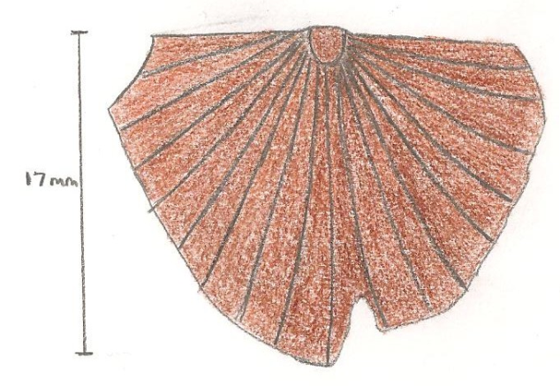Range of measurements of all specimens (in mm) – L = 5-17, W = 8-20.
Description: Differing colours- light brown to black, straight strophic hinge line, radially ornamented, fine equilateral ribbing (34 total), central and flattened umbo, fragments chipped off. 3 examples, no preferred orientation is evident.
Mode of Life and Guild: Lived in shallow, warm seas, filter fed by use of filamented lophophore, lived partly submerged in soft sediment substrate (pseudoinfaunal) judging by shape and thin size of shell. Endobyssate (free lying/shallow infaunal) suspension feeder.
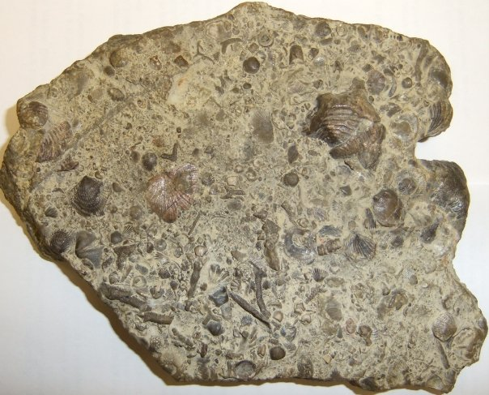
Brachiopod 1
Brachiopod 3
Brachiopod 5
Brachiopod 4
Brachiopod 2
Bryozoan
Coral
Trilobite pygidium
Crinoid ossicle

Brachiopod 2: Microsphaeridiorhynchus nucula 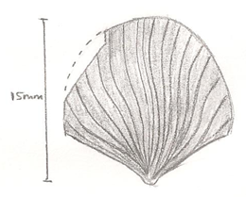
Fig. 4.
Measurements – L = 3-15, W = 4-14.
Description: Shells relatively small, concentric growth lamellae are rhythmical and numerous (7 in total), straight and angular hinge line upon umbo, concave/pronounced umbo protruding from pedicle valve, ornamental and fine ribbing. 33 examples, many of which are disarticulated. Due to the large sample size, there is no preferred orientation evident.

Fig. 3. An annotated picture of sample SL99. Red arrows show preferred orientation of bryozoans. Sample is 14 x 12 cm.

Attached to dead shells and substrate by plenipedunculate pedicle, streamlined so currents passed easily, filter fed on particles within currents. Pedunculate suspension feeder.
Brachiopod 3: Eospirifier radiatus
Fig. 5.
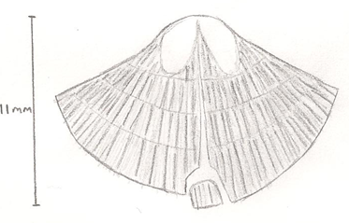Measurements – L = 5-9, W = 8-14.
Description: Straight and angular hinge line upon umbo, raised centre from hinge to shell edge, raised and concave umbo, maximum width of valve is located close to its mid-length, extremely finely ribbed, broken fragment evident in centre of shell. 2 examples. Similar orientation is evident at roughly 30⁰ from umbo direction.
Mode of life similar to brachiopod 2. Pedunculate suspension feeder.
Brachiopod 4: Howellella elegans
Fig. 6.
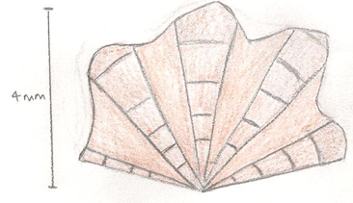Measurements – L = 5-6, W = 5-7.
Description: Straight hinge line, deep ribbing, thick shell, concentric growth lines, fragmented specimens, dorsal valve with sharply outlined fold bordered by deep furrows, fold originates at beak, maximum width of valve is located close to its mid-length, wavy/zigzagged edge. 3 examples, no preferred orientation seen.
Fixosessile, strong and long pedicle attachment allowed gathering of particles from currents, high energy environment due to thick, deep ribbing. Pedunculate suspension feeder.
Brachiopod 5: Leptaena depressa
Fig. 7.
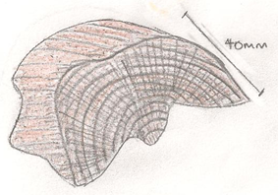Measurements – L = 20, W = 24
Description: Light brown in colour, large width and height-wards, pedicle valve concave, brachial valve convex, concentric and equally spaced growth lamellae protrude from valve, finely ribbed, fragmented but well preserved due to shell strength. 2 examples, one of which is an un-measurable fragment, no preferred orientation seen, lighter brown in colour to other specimens.
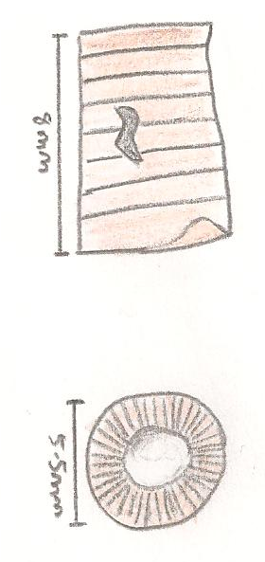
Pseudoinfaunal, lived on sea bed with half of shell buried by soft sediment (spanes acted as support and protection from predators but were lost in burial), other half of shell laid above which fed by filtering particles from water, liberosessile (laid with closed pedicle opening), thick shell resisted current velocity. Endobyssate suspension feeder.

Crinoid: Crotalocrinites rugosus
Fig. 8.

Measurements – L = 7, W = 5.
Description: Many fragmented/ disarticulated, variation in ossicle width, show synostosial articulation (Fig. 9). 18 separate examples, impossible to determine whether or not fragments could be of the same sample or not, no preferred orientation evident as many ossicles are seen vertically/in birds-eye view.
Fixosessile, attached by tube feet (bryozoan mounds provide attachment site), rheophilic filter feeder (seek current for nutrients), arms spread out to filter food particles, lived at <100m depth. Cemented epifaunal suspension feeder.
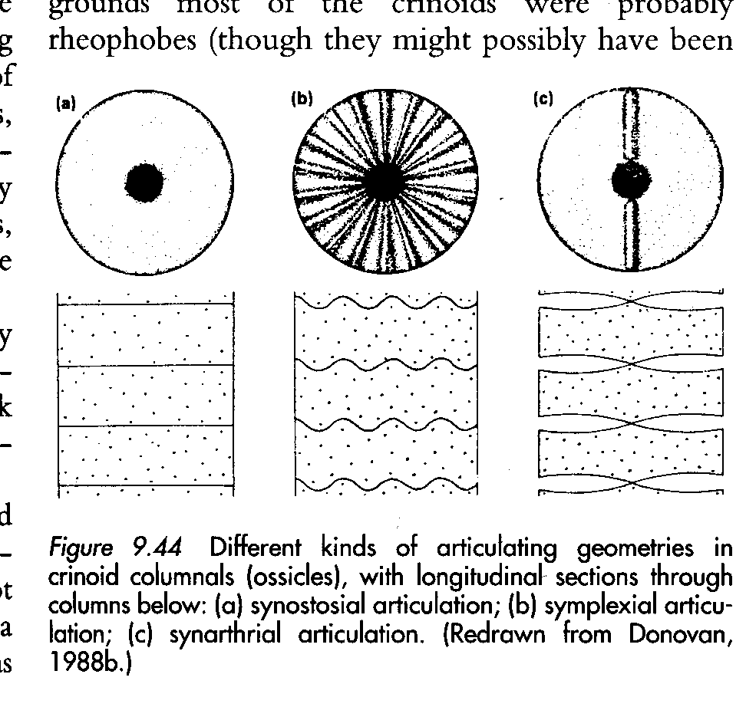
Fig. 9. The articulating geometry through the crinoids columnal (ossicle), with longitudinal section through column beneath. Evident is synostosial articulation (Clarkson, 1998).

Coral: Favosites gothlandicus
Fig. 10.
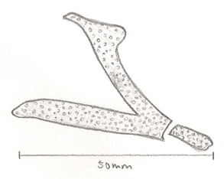
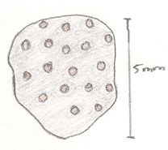
Fig. 12.
Measurements – L = 5-25, W = 5-20.
Description: Variation in size, composed of small corallites with tabulae, compound corallum, septa reduced to rows of spines or absent. 3 examples, no preferred orientation or clustering due to coloniality.
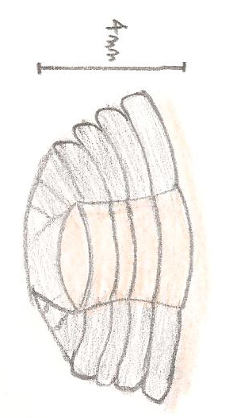
Always solitary and colonial suspension feeder, massive structure, not usually found near strong currents, ecologically zoned with respect to shoreline, water depth <50m. Cemented epifaunal suspension feeder.
Trilobite pygidium: Calymene blumenbachi
Fig. 11.
Measurements – L = 4, W = 4.
Description: One single trilobite pygidium with pleural field (4 pleura). With great difficulty can a species name can be assigned. Judging by the pygidium, it appears to belong to a species of calymene. The rest of its body is not seen in the sample, reflecting disarticulation and transportation.
Benthonic, soft-sediment/‘mud grubber’, scavenger, ecdysis allowed shedding of shell. Epifaunal scavenger.
Bryozoan: Batostomella
Measurements – L = 9-24, W= 2-4
Description: Variation in length, small linked zooids, black in colour with fine sediment filling zooid spaces, colonial. 13 examples, again it is difficult to determine a whole sample as fragmented parts may belong to the same specimen. A general orientation is evident (Fig. 3).
Colonial, lived in sub-littoral zone from 20-80m depth (Fig. 15), filter feeder (consume phytoplankton and micro-organisms from water using tentacles), sessile/rooted in soft sediment and erect giving greater feeding opportunity and protection from predators, flexible zoaria withstand current velocity. Cemented, epifaunal suspension feeder.
Sample SL99- Species | Sample Dominance | Sample Diversity | Sample SL45- Species | Sample Dominance | Sample Diversity
Amphistrophia funiculate | 3.9% | 4.23 | Kodonophyllum truncotum | 10% | 4.60
Microsphaeridiorhynchus nucula | 42% | 4.23 | Heliolites interstinctus | 11% | 4.60
Eospirifier radiatus | 2.6% | 4.23 | Phaenopora lindstromi | 46% | 4.60
Howellella elegans | 3.9% | 4.23 | Fenestella | 13% | 4.60
Leptaena depressa | 2.6% | 4.23 | Periechocrinites moniliformis | 9.7% | 4.60
Crotalocrinites rugosus | 23.1% | 4.23 | Stromatopora | 0.7% | 4.60
Favosites gothlandicus | 3.9% | 4.23 | Isorthis | 1.4% | 4.60
Calymene blumenbachi | 1.3% | 4.23 | Atrypa reticularis | 2.8% | 4.60
Batostomella | 16.7% | 4.23 | Halysites catenularius | 2.1% | 4.60
 |  |  | Resserella canalis | 1.4% | 4.60
 |  |  | Camarotoechia nucula | 1.4% | 4.60
Fig. 13. A table showing diversity and dominance figures for sample SL99 and SL45, respectively. As would be expected, diversity statistics are similar. However, dominance statistics vary vastly, without a single species being seen in both. samples.

Discussion
As is evident from the results, the assemblage is dominated by suspension feeders in a shallow marine, sub-littoral environment (Fig.14). Further to this, the brachiopods form the trophic nucleus of the suspension feeding chain within the Wenlock Limestone (Fig. 15).
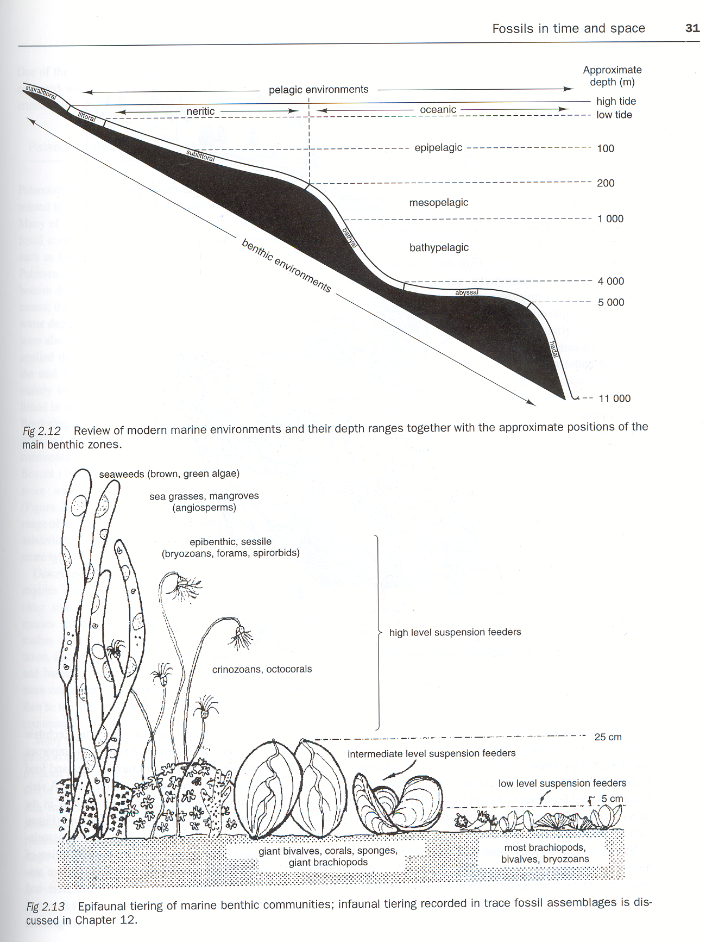

The five species of brachiopod exhibit slightly contrasting morphology in order to suit their mode of life; however they all belong to the trophic group of filter feeders. It is difficult to tell whether the brachiopods lived a fixosessile or liberosessile mode of life. This is also the case in determining whether species were rhizonpedunculate or plenipenduculate, as
Fig.14. A typical marine environment showing depth ranges and main benthic zones. It is thought sample SL99 comes from the sub-littoral zone, from a depth of around 10-50m (Benton and Harper, 1997).

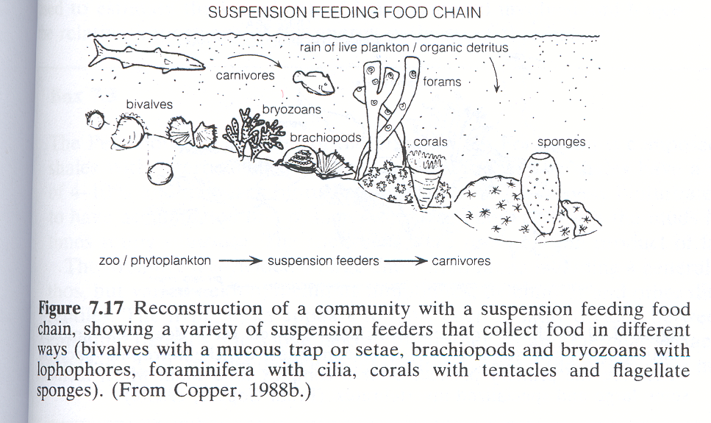
Fig. 15. A reconstruction of a suspension feeding food chain, collecting food in contrasting ways depending on respective guild and trophic group (Brenchley & Harper, 1998).

its respective pedicle or bysuss was destroyed by currents upon death and burial. Brachiopods are not excluded from turbulent environments (Thayer, 1975) as the strength of the pedicle allowed life in sub-tidal, high energy environments. Further evidence of this is seen in figure 13, whereby brachiopods clearly dominate the trophic nucleus.
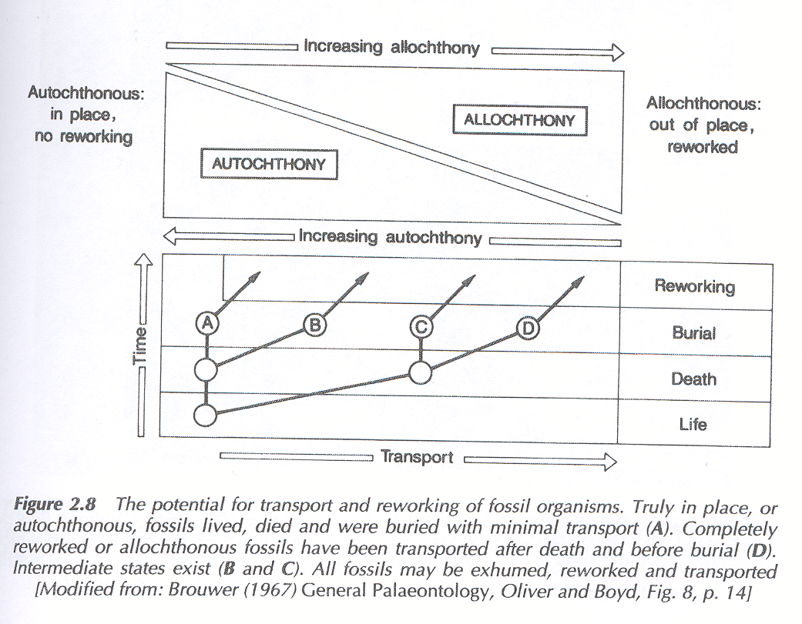
The sample as a whole shows very little correlation between orientations of specimen. The relatively high energy nature of the sub-littoral zone is likely to lead to mechanical destruction and
Key
Amphistrophia funiculate
Microsphaeridiorhynchus nucula
Eospirifier radiatus
Howellella elegans
Leptaena depressa
Crotalocrinites rugosus
Favosites gothlandicus
Calymene blumenbachi
Batostomella

Fig. 16. The difference between an autochthonous and allochthonous assemblages. (A) represents an autochthon, whereby a fossil lived, died and was buried with little transport. (D) represents an allochthon, whereby the fossil was transported after death, before burial. Intermediate states exist at (B) and (C). Dots indicate an interpretation where each species would place on the scale (Doyle, 1996).

re-working of shells as waves drag and batter organisms upon death. The effects of both bioerosion from bryozoans and biofragmentation from predators and scavengers will add to the effect of disarticulation. The possible correlation of bryozoan orientation reflects rapid burial in the rocks final stage of deposition. This would also explain the well preserved specimens which are evident, lying as close to life position of all species within the assemblage (on their side whereas they would usually be erect in life position). The similarity in orientation of eospirifier radiatus is likely to be coincidental as only two specimens are seen. If more specimens were present, a trend with greater reliability may be seen.
The moderate degree of fragmentation seen on the rock as a whole is due to its high energy environment of deposition. Most samples are well preserved; however some are not, for example many specimens of brachiopod 2. I believe this species is allochthonous and has been transported from a different community. A contrasting

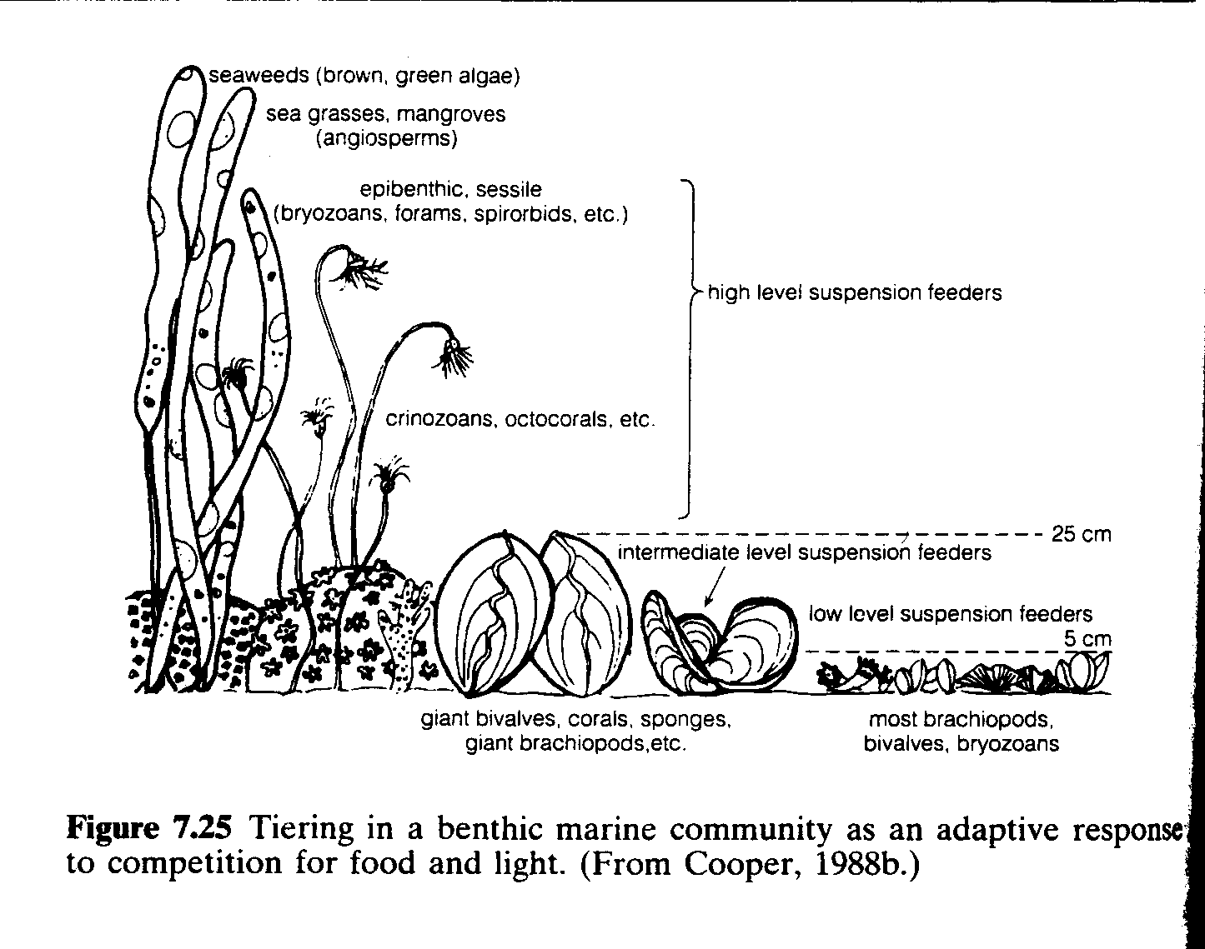
theory may be that due to its high degree of dominance, it represents a local species which has been deposited and re-worked. Most samples are fairly articulated and complete but this varies on a specimen level. The assemblage as a whole represents a neighbourhood assemblage, being disturbed and displaced from its original position, but remains in its original habitat. Of course, due to tidal recharge and current action, there are influxes of allochthonous species e.g. calymene blumenbachi (Fig. 16).
Many ecological factors control the fauna seen in the Wenlock limestone. Depth does not signify a primary control, but factors which vary with depth do, including pressure, substrate, salinity and food supply. These differ between organisms as some are able to tolerate varying amounts of each than others. However, the fauna seen represent a balance whereby an equilibrium is reached. Temperature, which decreases with depth, may be the most important (Boucot, 1975). A temperature of ~ 25⁰ upon deposition represents a good approximation for life in shallow seas during the Silurian (Fig. 17).
Fig. 18. A diagram to show tiering in a benthic marine community as a response to competition for food and light. Evident is the increase in the crinoids length and surface of gills in order to optimise feeding opportunity. Brachiopods increase the length of its lophophore however this cannot be seen on the scale of this picture (Benton & Harper, 1997).

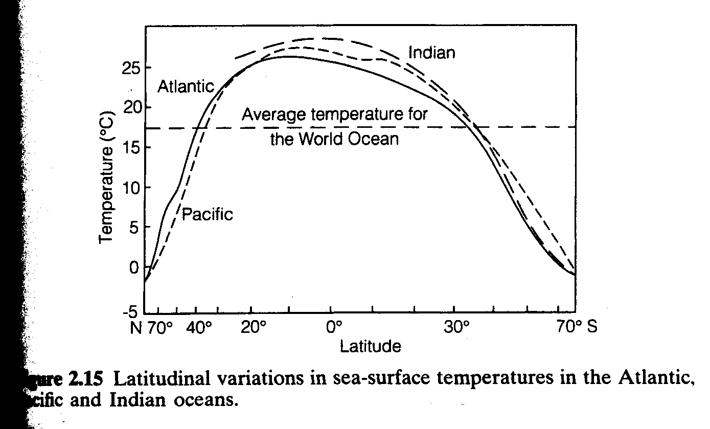 Members of most communities are forced to compete for food, light and space. This is also the case for the Wenlock Limestone assemblage. This ‘tiering effect’ results in organisms developing adaptive radiation strategies in order to derive food and nutrients (Fig. 18). It also minimised competition within the suspension feeding community. The trophic nucleus is dominated by suspension feeders, notably brachiopods. Bioturbation of sediment greatly affects the seen faunal distribution. Re-working of sediment by deposit feeders produces faecal rich sediment which is prone to suspension, inhibiting colonisation by filter feeders. This produces the separation between guilds in the assemblage, as suspension feeder’s favour less muddy sediments.
Fig. 17. A graph to show latitudinal sea-surface temperature variations for three world oceans (Brenchley & Harper, 1998). The joining lines represent an approximation of the temperature for its latitude upon time on deposition (judging by the average temperature of the Pacific Ocean today).

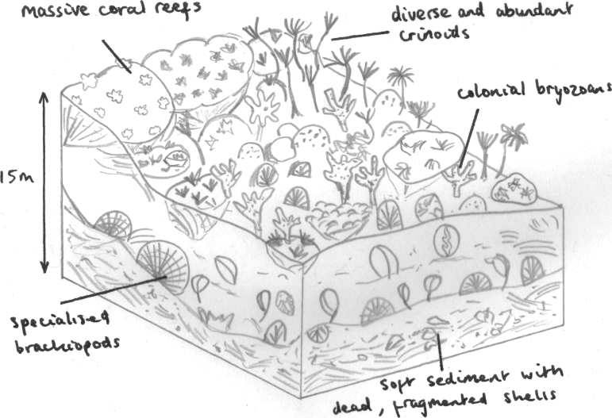 Following the Late-Ordovician extinction event, communities were forced to adapt and improve their mode of life. This reflected a pioneer stage of inhabitancy, whereby organisms lived basic modes of life in an attempt to establish a foothold in the sub-littoral zone. Based on the evidence seen in sample SL99 and others, I believe this was an equilibrium community (Fig. 19). This is backed up by the result of 4.23 on the margalef scale (Fig. 13), emphasising the diversity within the assemblage. Each organism had an established mode of life and a stable food chain would have been seen (ecological resource partitioning). Many developed specialist adaptations in order to improve life efficiency e.g. crinoids developed versatile holdfasts in order to allow the group to target soft sediments in deeper water, leading to diversification within previously uninhabited environments.
Fig. 19. A block diagram interpretation of a climax/ equilibrium, shallow marine system in the Silurian, teeming with life. Evident is the dominance of suspension feeding organisms. The assemblage reflects life in the sub-littoral zone, as relatively few epifaunal animals could survive the very high energy conditions of the upper shoreface. Also notable is the ‘tiering’ theory seen in marine benthic assemblages.
Conclusion
I believe the sample is an allochthonous taphocoenose, demonstrating the past effects of thanatocoenesis during death and decay. It is difficult to determine whether the rock as a whole reflects an autochthon or an allochthon. It is thought some species were transported from nearby
communities, notably calymene blumenbachi. This is evident by the disarticulation seen, demonstrating the effects of transportation due to current action in the sub-littoral zone. In contrast, the bryozoans batostomella are well preserved due to rapid burial. This re-emphasises the concept of a neighbourhood assemblage.
A key role resulting in equilibrium conditions within the community is that of taphonomic feedback. Upon death, brachiopods shells and fragments act as a settlement site for organisms e.g. corals within otherwise fine sediment. This stabilisation helps hugely, as relatively few epifaunal animals can survive the relatively high energy conditions of shallow seas.
It was originally hypothesised that the sample would be dominated by suspension feeders, notably brachiopods and a limited amount of guilds seen. This turned out to be correct, reflecting the oligotrophic conditions in which most organisms within the sample flourish. Brachiopods comprised 55% within the sample. Comparing this to another sample’s result, a similar trend was seen. A point worth noting is that in two different rocks from the same succession, no two species were the same. This demonstrates the wealth of life on the sea floor upon deposition.
An important factor to stress is that a fossil accumulation is commonly the result of winnowing and concentration of shells from several levels within sediment. The assemblage therefore does not represent a community living at a single time, but a time averaged product of mixing a succession of communities (Fürsich & Aberhan, 1990). The Wenlock Limestone therefore may represent species from communities of millions of years before, creating an even more significant error envelope.
References
BENTON, M. & HARPER, D. Basic Palaeontology (1997).
BOUCOT, A.J. (1971) Practical taxonomy, zoogeography, paleoecology, paleogeography, and stratigraphy for Silurian-Devonian brachiopods. Proceedings of the North American Paleontological Convention, Chicago, 1969 (F), pp 566-611.
BRENCHLEY, P. J. & HARPER, D. A. T. Palaeoecology: Ecosystems, environments and evolution (1998).
CLARKSON, E. N. K (1998). Invertebrate Palaeontology and Evolution, fourth edition, p299.
COOPER, P. (1988). Ecological succession in Phanerozoic reef ecolo-systems:Is it real? Palaios 3, 136-152.
DOYLE, P (1996). Understanding fossils. An Introduction to Invertebrate Palaeontology.
Fürsich, F.T. and Aberhan, M. (1990). Significance of time-averaging for palaeocommunity analysis. Lethaia 23, 143-152)
THAYER, C.W. (1975) Strength of pedicle attachment in articulate brachiopods:ecologic and paleoecologic significance. Paleobiology 1, 388-99.
Treatise on Invertebrate Paleontology, Moore, Editor (G) Bryozoa, Geological Society of America, University of Kansas Press.
WATKINS, R. Silurian Reef Dwelling Brachiopods and Their Ecological Implications. Palaios, (2000), V. 15, p112-119.
WOODCOCK, N. H & STRACHAN, R. Geological History of Britain and Ireland (2000), p169.
Sample SL45 data collected from Charlie Hartley. Sample photo courtesy of Jamie Foster.

